Ecology Big Ideas Name: ___________________________________ Block: ___

Objectives for this unit:
- Describe general factors regulating population size in ecosystems
- Describe common ecological relationships between and among species and their environments.
- Explain how energy flows through familiar ecosystems.
- Describe responses of an ecosystem to events that cause it to change.
- Describe how carbon and soil nutrients cycle through selected ecosystems

What do you think controls the size of a population of organisms?

Use Unit 2 of your text to help you understand the following words: define bolded terms, at come up with examples when asked.
Ecosystem:
Ex:
Biome:
Ex:
Community:
Ex:
Population:
Ex:
Biotic Factors:
Ex:
Abiotic Factors:
Ex:
A soil sample near a pond contains the following materials: dead insects, iron, leaf particles, traces of mercury, bacteria, and various fungi. Which items are biotic and which items are abiotic?
Biotic: Abiotic:
List 3 biotic factors of a pond:
List 3 abiotic factors of a pond:
Abiotic Factors: Light, Temperature, and precipitation
Light:
Latitude:
Duration:
Draw two pictures of the earth and sun for both winter and summer using the northern hemisphere as your reference. What is the relationship between latitude and duration for winter and summer?

Why is light most intense near the equator?

What time of the year is it when there is A. 24 hour darkness at the north pole? B. What about 24 hours of daylight?
A. B.
Which city would have the longest duration daylight in mid June, Novi, Michigan or Santiago, Chile?

Climatographs: (Adapted from Pearson Exploring Life)
Two primary abiotic factors that have major impacts on the type of biome are precipitation and temperature. In this activity you will learn how to interpret a climatograph, a graphical display of annual temperature and precipitation. Then you will plot a climatograph for the temperate deciduous forest biome. Finally you will compare the climatographs of several different biomes.
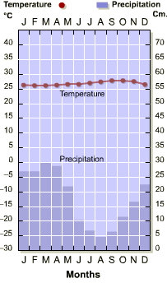
- The left hand y-axis represents what information? The right hand y-axis represents what information?

- The letters along the x-axis represent what information?

- What are the units of temperature? What are the units of precipitation?

- What is the average temperature and precipitation for the month of January? What are these averages for the month of July?

- Overall, looking at this data, how would you describe the climate of this biome?

Now use the information in the table below to make your own climatograph for a Temperate Deciduous forest in North America.
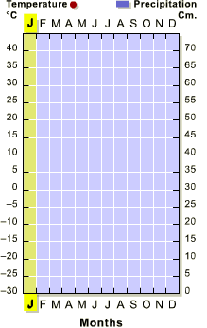
Month | Temperature (Celsius) | Precipitation (cm)
J | -3.8 | 5.5
F | -4.4 | 6
M | 0.8 | 7.1
A | 7.5 | 9.5
M | 13.8 | 9.5
J | 18 | 7.6
J | 20.8 | 9.6
A | 19.5 | 10
S | 14.6 | 8.7
O | 8.6 | 8.8
N | 3.5 | 7.9
D | -3.2 | 7
- What is the coldest month? Wettest month?

- If you love playing sports outdoors during the summer, you know that the best days are when the sun is shining and the humidity is low. Using the data you just created, what is the most favorable month for outdoor activities? Why?

Compare the climatographs of all the biomes on the next page. Use them to answer the questions below.
- A deciduous tree in the temperate deciduous forest loses its leaves during the winter and replaces them the following spring. How does this adaptation reflect the yearly temperature pattern of this biome? Based on the annual temperature pattern of a tropical rainforest, would you expect to find deciduous trees in this biome?

- What is the annual total precipitation in the desert biome? What kinds of adaptations might enable the animals and plants in this biome to survive?

- Find the climatograph of the biome that shows a period of heavy rainfall followed by three months with no precipitation. What kinds of vegetation and animals might be found in this climate?

- Compare the climatographs of both the temperate grassland and savanna biomes. Use the data to explain why they are similar and why they are different with regard to vegetation.

- Look at the bell-shaped curves in the climatographs that represent the temperature fluctuations in the temperate deciduous forest, coniferous forest and tundra. Then, think about the predominant vegetation in each of these biomes. How is the vegetation adapted for each of these biomes?

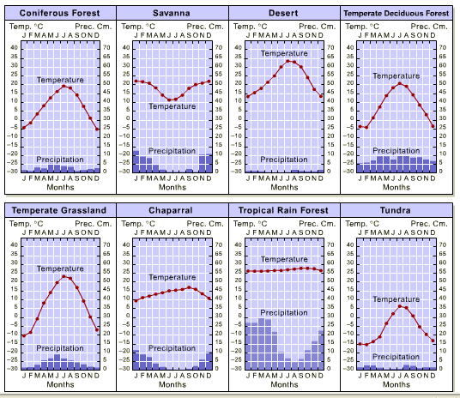

Population Size
What general factors might regulate the size of a population?

Carrying Capacity:
What environmental (biotic or abiotic) factors might affect the carrying capacity of a population of sunfish in a pond?
Biotic: Abiotic:
Ecological Relationships sometimes affect the size of a population
Competition: Interspecific: Intraspecific:
Symbiotic Relationships: (Pg. 44-45)
Parasitism:
Commensalism:
Mutualism:
Producers (Autotrophs):
Ex:
Consumers (Heterotrophs):
Ex:
Herbivores:
Ex:
Carnivores:
Ex:
Ominvores:
Ex:
Decomposers:
Ex:
Energy Flow: Biomass Energy Pyramids
Only a fraction of the available energy is used for growth and incorporated in the plant or animal itself at each stage of the food web.
Humans
Chickens
Corn
Mass(g) X % passed up = final mass passed up (g)
1 human = 50 kg

In this example only 10% of the biomass and energy is passed up the food chain.

- How many kilograms of chicken can be supported by 3500 kg of corn?

- How many kilograms of humans can be supported by the mass of chickens from #1?

- How many kilograms of corn must be grown to support 10 human vegetarians?

- If 145,000 kg of corn was used to feed chickens which were then fed to humans how many humans could the corn support?

- If the humans in this pyramid consumed corn instead of chickens, how many humans could be supported by 145,000 kg of corn?

- Why do you think we send corn to help feed people in struggling nations instead of chickens?

- In the pyramid of energy the greatest amount of energy is found at the _____________ and the least amount is found at the _________. Therefore in a community the organisms present in the greatest numbers and having the greatest total mass are at the _________________.
Use the Food Chains, Food Web, and Energy and Biomass Pyramid diagrams on the previous page to answer the following questions and those on the next page. Food Web Questions
- What organism would be affected if the population of rabbits is increased? How might they be affected?

- Which organisms would be affected if the population of owls decreased? How would they be affected?

- Which organism would be affected if the population of trees, shrubs, and grasses decreased? How would they be affected?

Energy and Biomass Pyramid Questions Due to severe climatic conditions the amount of energy and biomass passed up the pyramid is only 8%.
- How many kilograms of cow can be supported by 2500kg of rice?

- How many kilograms of humans can be supported by the mass of cows from #1?

- How many kilograms of rice must be grown to support 12 human vegetarians?

- If 125,000 kg of rice was used to feed cows which were then fed to humans how many humans could the rice support?

- If the humans in this pyramid consumed rice instead of cows, how many humans could be supported by 125,000 kg of rice?

- In this example the greatest amount of energy is found in the ________________________
- In this example the population that with the lowest numbers and total mass is the ___________
- Within a community, the organisms present in the greatest numbers and having the greatest total mass are: (circle one) Producers Consumers
Nutrient Cycles
Carbon - Oxygen Cycle
Photosynthesis:
H2O (water) + CO2 (carbon dioxide) + Energy from sun → C₆H₁₂O₆ (sugar)
Cellular Respiration:
C₆H₁₂O₆ (sugar) → H2O (water) + CO2 (carbon dioxide) + Energy to do work
Trace the flow of carbon and oxygen in the diagram below. Indicate where cellular respiration is occurring and where photosynthesis is occurring.

Greenhouse effect:

Global Warming:

The processes of photosynthesis and cellular respiration generally balance. However scientists have noticed some change in this balance. The graph below represents the first set of data and shows the average annual CO₂ concentration. CO₂ levels are recorded in parts per million (ppm). This is the number of CO₂ molecules in every one million molecules of the atmosphere. Study this graph and answer the questions below it.
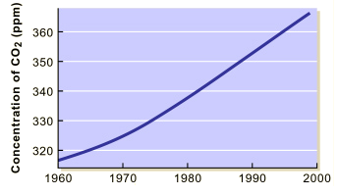
- What conclusions can be drawn from this graph?

- Why do you think CO2 levels are changing?

- How might this affect the Carbon -Oxygen Cycle?

Nitrogen Cycle
Read Pages 788-790 define these terms and answer the following questions.
Nitrogen fixation:
Ammonification:
Nitrification:
Denitrification:
- Why do humans need nitrogen?

- If Nitrogen gas makes up 78% of the air that we breathe, then why are nitrogen fixing bacteria so important to us?

- What abiotic factors might affect the rate of nitrogen cycling?

Label the four processes of the nitrogen cycle in the diagram below:
Now try to connect the following objects through the processes of the Nitrogen cycle:

- Nitrogen-fixing bacteria help cycle nitrogen through ecosystems. How do they do this?

- Carbon is found in the tissue of living things in the form of _____________________

Read the article on the everglades on page 60 of your textbook. Answer questions below on a separate sheet of paper.
- Why are the everglades changing?
- How has the phosphorus cycle in the everglades been effected by Agriculture?
- What are the pros and cons to of diverting water from the everglades?
Changing Ecosystems
What types of things might cause an ecosystem to change?

Read Pages 67-69 and define the following terms and answer the following questions
Succession:
How is interspecific competition related to succession?

Pioneer:
Describe some examples of pioneer species and what makes them ideal pioneer species. Are Maples and Beeches Pioneer species? Why or why not?

Sketch what might happen over time if we stopped cutting the soccer field.

Present In 10 years In 20 years
What external forces might affect ecological succession?

Biodiversity:
What is the relationship between the stability of an ecosystem and its biodiversity?

