Carbon: Transformations in Matter and Energy (Carbon TIME): Project Summary
Principal investigator: Charles W. Anderson, Michigan State University
Co-principal investigators: Dan Gallagher, Seattle Public Schools; Kathleen Schwille, National Geographic Society; Mark Wilson, Berkeley Education and Assessment Research Center
Senior researchers: Jenny Dauer, Elizabeth Wolzak, Jennifer Doherty, Beth Covitt, Lindsey Mohan
Graduate student researchers: Li Zhan, Jiwon Kim, Hannah Miller
Undergraduate researchers: Courtney Lannen, Kathryn Oleszkowicz, Etiowo Usoro
Teacher/developers: Marcia Angle, Becky Drayton, Mary Grintals, Cheryl Hach, Debi Kilmartin, Liz Ratashak
Project Manager: Staci Sharp
Contents
Carbon: Transformations in Matter, and Energy (Carbon TIME) 2
Teaching Units Focusing on Carbon-transforming Processes in Familiar Systems 2
Teaching Support 1: Teachers’ content understanding 3
Teaching Support 2: Goals for student learning 4
Inquiry practices 4
Accounts goals: Practices or strategies and learning progression levels 5
Teaching Support 3: Formative Assessment 9
Teaching Supports 4 and 5: Scaffolding Inquiry and Accounts 10
Investigations: Predict, explain, observe, explain activity sequences 11
Learning scientific accounts through cognitive apprenticeship activity sequences 11
Teaching Support 6: Logistics 12
Summary: Helping Students Uncover the Chemical Basis for Life and Lifestyles 12
Appendix A: Inquiry Learning Progression Framework 13
Appendix B: Matter and Energy Process Tools 15

This research is supported in part by a grant from the National Science Foundation: A Learning Progression-based System for Promoting Understanding of Carbon-transforming Processes (DRL 1020187). Any opinions, findings, and conclusions or recommendations expressed in this material are those of the author(s) and do not necessarily reflect the views of the National Science Foundation.

Please visit our website: http://edr1.educ.msu.edu/EnvironmentalLit/index.htm

Carbon: Transformations in Matter, and Energy (Carbon TIME)
In the Carbon TIME project we are developing a series of six teaching modules that can be used at the middle school or high school level. They are based on research focusing on learning progressions leading to environmental science literacy, described below. The purpose of these units is to enable students to uncover the chemical basis of life and lifestyles.
The chemical basis of life and lifestyles lies in carbon-transforming processes in socio-ecological systems at multiple scales, including cellular and organismal metabolism, ecosystem energetics and carbon cycling, carbon sequestration, and combustion of fossil fuels. These processes: (a) create organic materials (photosynthesis), (b) transform organic materials (biosynthesis, digestion, fermentation), and (c) oxidize organic materials (cellular respiration, combustion). We think that it is important for students to understand carbon-transforming processes for many reasons; among them: the primary cause of global climate change is the current worldwide imbalance among these processes.
The reason these processes are unbalanced lies in the nature of organic materials: foods, fuels, and biomass (the tissues of living and dead organisms). All organic materials contain carbon and hydrogen, and store chemical energy in their carbon-carbon and carbon-hydrogen bonds that can be released when those materials combine with oxygen.
Virtually all of the chemical energy on Earth is stored in organic materials, and we need that chemical energy to maintain our lifestyles, so we burn organic materials—especially fossil fuels. So understanding these process is essential for students to act as informed citizens—what we call environmental science literacy.

Teaching Units Focusing on Carbon-transforming Processes in Familiar Systems
What does it mean for students to understand carbon-transforming processes? One key for us is that students must learn that all carbon-transforming processes are chemical changes and learn to uncover the chemical changes in familiar systems and events. Each of our six units focuses on familiar systems and events that involve carbon-transforming processes. In brief, here are the units and the processes that each unit focuses on:
- Systems and Scale: Our first unit introduces students to key ideas that form the basis for all the other units by developing a scientific account of organic and inorganic materials, and how combustion transforms organic materials to inorganic materials and chemical energy to heat and light.
- Plants: Plant growth starts with a process of photosynthesis, using the energy from sunlight to create an organic substance (glucose) from inorganic materials—carbon dioxide and water. Plant cells grow by transforming glucose and soil minerals into all the complex organic materials that plants are made of, including fats, proteins, and complex carbohydrates—the process of biosynthesis. Finally, plants get the energy they need to function by oxidizing glucose—the process of cellular respiration.
- Animals: Animals cannot create organic materials like plants, so they must find organic materials—food—and break the complex organic molecules into simpler molecules that their cells can use—the process of digestion. Animal cells are like plant cells in that they can grow by making complex organic molecules out of simpler molecules—biosynthesis again—and that they get energy by oxidizing organic materials—cellular respiration.
- Decomposers: Although decomposers (fungi and aerobic bacteria) appear very different from animals, aerobic decomposers (fungi and aerobic decomposing bacteria) are biochemically very similar. Like animals, they rely on digestion (outside the body in the case of decomposers) to break complex organic molecules into simpler organic molecules. The cells of decomposers also grow through biosynthesis and obtain energy through cellular respiration.
- Ecological Carbon Cycling: These processes, photosynthesis, biosynthesis, digestion, and cellular respiration, are constantly occurring in every ecosystem. In combination, they constitute food chains, food webs, and energy and biomass pyramids—all components of the ecological carbon cycle, which cycles matter between inorganic carbon dioxide and organic materials.
- Human Energy Systems: Many aspects of our lifestyles, from driving cars to turning on light bulbs, depend on energy that can be traced back to combustion of fossil fuels, and we need to understand how our lifestyles affect the balance between organic and inorganic materials on Earth.
The units are designed to support teachers in six ways:
Teaching Support 1: Teacher’s content understanding. We want each unit to provide accurate information about the knowledge and practices of the unit and their importance for environmental science literacy.
Teaching Support 2: Goals for student learning. Our goals in each unit include two important kinds of scientific practices that students should become more proficient in:
- Inquiry practices: Measurement, arguments from evidence (claims, evidence, reasoning), collective validation.
- Accounts practices: Goals for student accounts of carbon-transforming processes:
  - Organized around three questions (see page 4 below):
    - Where are atoms moving?
    - What’s happening to carbon atoms?
    - What’s happening to chemical energy?
  - Different goals for students at different learning progression levels
Teaching Support 3: Formative assessment. Each unit has is associated with a pretest and embedded formative assessments that track students’ progress in learning progression levels and recommend appropriate activities for students at different levels.
Teaching Support 4: Scaffolding inquiry. Each unit includes a PEOE sequence (predict-explain-observe-explain; see Figure 1 on page 8) that focuses on mass/gases accounts for the systems that the unit focuses on and scaffolds students in the two inquiry practices—measurement and claims-evidence-reasoning (argument from evidence).
Teaching Support 5: Scaffolding accounts. Each unit includes cognitive apprenticeship activity sequences (establishing the problem, modeling, coaching, fading, maintenance; again see Figure 1 on page 8).
Teaching Support 6: Logistics. Each unit provides logistical support for unit activities: timeline and detailed lesson plans, materials, videos, etc.
The sections below summarize how the units will be designed to provide each of the teaching supports.

Teaching Support 1: Teachers’ content understanding
Each unit will include an introduction that explains the big ideas of the project as a whole and their significance, including (a) their place in the science curriculum, such as the new NRC Framework for K-12 Science Education: Practices, Crosscutting Concepts, and Core Ideas, and (b) their significance for environmentally responsible citizenship.

Teaching Support 2: Goals for student learning
Our units share the common purpose of helping students to analyze familiar systems and events, from plant growth to people losing weight to turning on light bulbs, by uncovering the carbon-transforming processes hidden within them. We have found through our research on learning progressions that this is a complex and difficult challenge for most students; they see many aspects of those familiar events, but it is difficult for them to discover the underlying chemical changes. Therefore, our goals for the units focus on practices that students can engage in to investigate and explain these processes. We hope to help students master both inquiry practices and accounts practices (i.e., practices for scientific predictions and explanations).

Inquiry practices
Each unit focuses on three types of inquiry practices:
- Making careful measurements of mass and gas exchange
- Constructing arguments from evidence: that there is a negative correlation between biomass/organic matter and carbon dioxide.
- Collective validation: focusing on patterns across observations by multiple groups of students and reaching consensus about the nature and meaning of those patterns.
Inquiry Practice #1: Careful measurement of mass and gas exchange. Outside of school—and especially outside of the science classroom—students make countless observations of their world, and for these observations seeing is believing. What is not seen is ignored and goes unexplained. Yet, some of the most important changes happening in the physical world are ones not visible to the naked eye. One goal of these materials is to help students move toward measured observations of their world. Making measured observation requires students to use scientific equipment—sensors, balances, and microscopes—that help students access changes that cannot be felt or seen. It also requires students to engage in practices of making careful measurements and comparing measurements and observations with those of the larger classroom community.
Inquiry Practice #2: Arguments from evidence. In addition to learning to make careful observations of their world, students also need to learn why we make such observations, and how to use evidence in their reasoning. Another goal of these materials is to help students construct arguments from evidence. Constructing arguments from evidence is a practice where students will link claims (their accounts of carbon transforming processes) with evidence (their observations and measurements) through reasoning (their explanations of how the evidence supports their claims).
The pattern in data we want students to develop across these units is that in all of these processes there is a negative correlation between organic matter and carbon dioxide.
- As plants take in CO₂ (decreasing CO₂ levels around the plant) biomass increases.
- As a fuel burns, the organic matter decreases, but the CO₂ levels in the air around the fuel increase. This is also true of process of cellular respiration—in plants, animals, and decomposers.
These materials are based on the assumption that students will enter the classroom with existing explanations that, so far, have been useful to them. Through careful observation and measurement, students begin to extend their experiences and acquire new evidence not accounted for in their initial explanations (e.g., mass measurements, gas concentrations around plants). In fact, some evidence will contradict what students initially believed to be true. In this way, students learn to construct arguments from evidence by testing their initial explanations to see where those explanations are supported or fall short, and working toward developing an explanation that is supported by all the evidence.
Inquiry Practice #3: Collective validation. We want students to understand that the most reliable conclusions are based on multiple observations and consensus among the people doing the research (the students in this case) about the patterns in data and the meanings of those patterns. This process is essential to learning science because it conveys a message about the ultimate source of authority in science: The authority of evidence is ultimately more important than the authority of people—even respected people like teachers and textbook authors.
Inquiry learning progression framework. We have begun to work on a learning progression framework for the three inquiry practices. A key idea for us is that sophisticated inquiry practices are essentially ways of dealing with uncertainty: People who are good at scientific inquiry know how to identify uncertainty in measurement, in argumentation, and in collective validation, and have strategies for reducing that uncertainty. Our preliminary thoughts about an inquiry learning progression framework are in the Appendix.

Accounts goals: Practices or strategies and learning progression levels
Inquiry is important in our units, but it is not the primary way that we expect students to learn how to account for (explain and predict) carbon-transforming processes. The units are also designed to explicitly teach accounts of the chemical basis of life and lifestyles. Accounts of carbon transforming processes are complex. They involve: (a) connecting multiple scales: macrosopic, cellular, atomic-molecular, large (ecosystem and global) scale, (b) tracing the movements of materials through different structures in systems, and (c) tracing transformations in matter and energy
We have concluded that in the pilot versions of the units the accounts were TOO complex: Middle school students in particular, but also a majority of high school students, failed to see the essential patterns in carbon-transforming processes (see the discussion of learning progression levels below). So our revised units have “stripped down” the accounts to the answers to three essential questions. These questions along with rules that we will expect students to follow and evidence we will expect them to look for in answering them, are presented in Table 1 below.
Table 1: The Three Questions
Question | Rules to Follow | Evidence to Look For
The Movement Question: Where are atoms moving?  Where are atoms moving from?  Where are atoms going to? | Atoms last forever in combustion and living systems  All materials (solids, liquids, and gases) are made of atoms | When materials change mass, atoms are moving  When materials move, atoms are moving
The Carbon Question: What is happening to carbon atoms?  What molecules are carbon atoms in before the process?  How are the atoms rearranged into new molecules? | Carbon atoms are bound to other atoms in molecules  Atoms can be rearranged to make new molecules | The air has carbon atoms in CO₂  Organic materials are made of molecules with carbon atoms  - Foods  - Fuels  - Living and dead plants and animals
The Energy Question: What is happening to chemical energy?  What forms of energy are involved?  How is energy changing from one form to another? | Energy lasts forever in combustion and living systems  C-C and C-H bonds have more stored chemical energy than C-O and H-O bonds | We can observe indicators of different forms of energy  - Organic materials with chemical energy  - Light  - Heat energy  - Motion
Comments on goals based on the Three Questions. Our focus on the Three Questions arises from our reading of the data from the first pilot tests of our units during the 2011-12 school year, as well as our reading of data from other projects (e.g., Jin & Anderson, accepted). We are convinced that our first priority for student learning should be to engender a sense of necessity about conservation of matter and energy, along with the ability to apply these principles to carbon-transforming processes. Our rationale for this goal is explained in the section on learning progression research, below.
In this goal we are aligned with the recently released Framework for K-12 Science Education Standards (http://www.nap.edu/catalog.php?record_id=13165), which has this statement about the of the role of matter and energy in scientific knowledge and practices:
One of the great achievements of science is the recognition that, in any system, certain conserved quantities can change only through transfers into or out of the system. Such laws of conservation provide limits on what can occur in a system, whether human-built or natural. This section focuses on two such quantities, matter and energy, whose conservation has important implications for the disciplines of science in this framework. The supply of energy and of each needed chemical element restricts a system’s operation—for example, without inputs of energy (sunlight) and matter (carbon dioxide and water), a plant cannot grow. Hence it is very informative to track the transfers of matter and energy within, into, or out of any system under study.
….
The ability to examine, characterize, and model the transfers and cycles of matter and energy is a tool that students can use across virtually all areas of science and engineering. And studying the interactions between matter and energy supports students in developing increasingly sophisticated conceptions of their role in any system. However, for this development to occur, there needs to be a common use of language about energy and matter across the disciplines in science instruction. (NRC, 2011, p. 4-9).
We note that the Framework presents essentially a nineteenth-century conception of energy, treating matter and energy as separate entities that are independently conserved, ignoring the equivalencies of relativity and quantum mechanics. We share the judgment of the authors of the NRC Framework that this is an appropriate goal for high school science learning.
There are other ways in which the Three Questions rely on simplified models of matter and energy. With respect to matter, we have reduced the hierarchy of scales (largely ignoring cellular-scale systems and processes) and simplified the epistemology of atomic theory. We treat atoms and molecules as basic, factual subsystems rather than as models invented to explain empirical observations, and we rely on authority to present a straightforward rule of evidence with respect to the Movement Question: Changes in mass equal movement of molecules. In calling our second question the Carbon Question (rather than, for example, the Molecules Question), we signal our primary interest in tracking carbon atoms through chemical changes.
The physical science section of the Framework suggests that a focus on “forms of energy” is oversimplified, and high school students should achieve a deeper understanding:
The idea that there are different forms of energy, such as thermal energy, mechanical energy, and chemical energy, is misleading, as it implies that the nature of the energy in each of these manifestations is distinct when in fact they all are ultimately some mixture of kinetic energy, stored energy, and radiation. Furthermore, what is meant by the first three terms above is seldom precisely defined. It is likewise misleading to call sound or light a form of energy; they are phenomena that, among their other properties, transfer energy from place to place and between objects. (NRC, 2011, p. 5-13)
We argue that the model proposed by the Framework, while scientifically elegant, is too dependent on a detailed mastery of atomic-molecular theory to be achievable for most high school students. High school students continue to need a way to link the concept of energy to observable and perceptual phenomena in real life. “Forms of energy” is a tool for students to make that linkage. In particular, associating chemical energy with specific configurations of atoms in organic molecules and tracing energy separately from matter are essential for analyzing biochemical systems.
We also simplify the treatment of energy in other ways: we ignore gravitational and some other forms of energy; we do not distinguish between heat and thermal energy or between motion and work. We simplify the Second Law of Thermodynamics by not mentioning the concept of entropy, though we do emphasize degradation of energy: Energy is not like matter in that it cannot be recycled. All processes change energy from more useful to less useful forms, especially low-grade heat.
We argue below that these simplifications will make it easier for students to develop a sense of necessity about conservation of matter and energy and an understanding of carbon-transforming processes that is both practical and productive. When students succeed in using these strategies to analyze familiar systems and events, then we feel that they have made substantial progress toward our overall goal: They are able to uncover the chemical basis of life and lifestyles. And they will be well prepared to act as informed citizens around issues that involve carbon cycling and its role in climate change.
Our goals are informed by key results from our research on learning progressions, described below.
Empirical learning progression levels. We have found that in order to achieve our program goals, students must learn new knowledge and practices (described above). Underlying those changes, however, is an even more fundamental kind of learning—what we refer to as mastering scientific discourse.
Our everyday accounts of carbon-transforming processes are based on force-dynamic discourse or reasoning. Force-dynamic reasoning construes the events of the world as caused by actors (including people, animals, plants, machines, and flames), each with its own purposes and abilities, or by natural tendencies of inanimate materials. In order to accomplish their purposes, the actors have needs or enablers that must be present. For example, force-dynamic reasoning explains the growth of a tree by identifying the actor (the tree), its purpose (to grow), and its needs (sunlight, water, air, and soil). Force-dynamic predictions involve identifying the most powerful actors and predicting that they will be able to overcome antagonists and achieve their purposes as long as their needs are met.
This approach to reasoning about socio-ecological processes contrasts sharply with principled scientific discourse, which construes the world as consisting of hierarchically organized systems at different scales. Rather than identifying the most powerful actors, scientific reasoning sees systems as constrained by fundamental laws or principles, which can be used to predict the course of events. Each of our learning progressions involves students learning to apply fundamental scientific principles to the phenomena of the world around them.
So it is useful to think of learning science as like learning a second language. Students at the beginning of the learning progression are monolingual: They have mastered force-dynamic discourse but know little of the nature and power of scientific discourse. So our goal is to help students become “bilingual,” able to use force-dynamic or scientific discourse as the occasion demands. This is a difficult goal in part because force-dynamic and scientific discourse often use the same words (e.g., energy, growth, food, nutrient, matter) with different meanings. The differences can remain hidden to both teachers and students, creating the appearance of common understanding while profound differences remain.
We define students’ progress toward mastering scientific knowledge, practices, and discourse in terms of four levels of achievement, ranging from Level 1 (completely dependent on force-dynamic discourse) to Level 4 (able to choose between force-dynamic and principled scientific accounts of carbon-transforming processes). Very briefly, the levels we have identified are as follows:
Level 1: Pure force-dynamic accounts: Students have no choice but to rely on force-dynamic discourse. Their accounts focus on actors, enablers, and natural tendencies of inanimate materials, using relatively short time frames and macroscopic scale phenomena.
Level 2: Elaborated force-dynamic accounts: Students’ accounts continue to focus on actors, enablers, and natural tendencies of inanimate materials, but they add detail and complexity, especially at larger and smaller scales. The include ideas about what is happening inside plants and animals when they grow and respond, for example, and they show awareness of larger scale connections among phenomena such as food chains and how decay enriches the soil.
Level 3: Incomplete or confused scientific accounts: Students show awareness of important scientific principles and of models at smaller and larger scales, such as cells, atoms and molecules, and cycling of gases and materials in ecosystems. They have difficulty, though, connecting accounts at different scales and applying principles consistently. In particular, they often confuse matter and energy and fail to account for the mass of gases in their accounts.
Level 3: Incomplete or confused scientific accounts: Students successfully apply fundamental principles such as conservation of matter and energy to phenomena at multiple scales in space and time. In general, our descriptions of Level 4 performances are consistent with current national science education standards and with the draft framework for new standards.
Levels of achievement for teaching units. We have found that majority of middle and high school students are at Level 2 before they begin our units. Rather than have separate middle school and high school units, we are defining our goals in terms of learning progression levels. There are not very many Level 1 students in middle and high schools, so we combine Levels 1 and 2. That makes our goals something like this:
- For students starting at Level 2 (almost all middle school and initially a majority of high school students, too), we would like them to achieve Level 3, which we believe is an essential step toward Level 4.
- For students starting at Level 3 (hopefully a majority of high school students for later units), we would like them to achieve Level 4.
BUT there is a problem with empirical level 3 as described above (and in more detail in research reports): Level 3 students are often confused, not just about details, but about fundamental principles of matter, energy, and scale. So for these units we have tried to define a “Teaching Level 3” that has two key qualities: The most important change we have made is to describe a distinction between what we call “empirical Level 3” (the kinds of mid-level responses that we have typically seen from high school and college students) and “productive Level 3” (the kinds of mid-Level responses that indicate students making good progress toward Level 4). We mean two things by “productive:”
- Productive for students in their terms: They develop new knowledge and practice that is personally satisfying
- Productive in terms of future learning: Level 3 serves as an effective transition from Level 2 to Level 4
We are not convinced that the empirical Level 3 responses we currently see in high school and college students are productive in either of those terms. These accounts generally treat conservation laws as facts. Accounts (explanations and predictions) are constructed out of these “facts” along with others, but with a few missing. But which “facts” are missing is vitally important—the difference between accounts that are collections of ideas and accounts that are well-reasoned attempts to make sense of a process with limited information.
In contrast, productive Level 3—our goal for Level 2 learners—treats conservation laws as rules and tools for analysis (Jin & Anderson, in press). Missing details don’t affect a sense of necessity associated with these rules. Here are hypothetical contrasting explanations of weight loss that illustrate the difference between the two types of accounts.
- Empirical Level 3: The man loses weight through the process of cellular respiration, which converts his fat into energy and carbon dioxide
- Productive Level 3: The fat is being used for energy, but the atoms in the fat have to go somewhere. I guess I’m not quite sure where they go.
Several lines of evidence convince us that the phrase “converts his fat into energy” in the first response is not a casual error for most students; rather, it indicates a fundamental failure to understand and apply conservation laws. We would much prefer to see responses like the second one, which recognizes the fundamental importance of conservation of matter and recognizes a need for further learning. Our instructional goal is to do a better job of helping Level 2 students move to a productive Level 3, then on to Level 4. Table 2 describes these levels for the Three Questions.
Table 2: Level 2, Productive Level 3, and Level 4 for Accounts Practices
Question | Level 2 | Productive Level 3 | Level 4
The Movement Question: Where are atoms moving? | Growth and weight gain as actions requiring energy, but not necessarily matter  Weight loss as result of consumption/destruction of food, fat, or fuel  Gases as weightless | Sense of necessity for connection between mass changes and movement of atoms: If something gained mass, atoms must have moved into it  Sense of necessity for mass losses and gains: If something gained mass, something else (the source of the atoms) must have lost mass  Gases as forms of matter made of atoms and having mass  Incomplete details about structure and function | Successfully tracing materials though systems:  - E.g., food from digestive system to blood to muscle cells; CO₂ through blood to lungs and out of body  - E.g., organic matter through trophic levels
The Carbon Question: What is happening to carbon atoms? | Foods and fuels as enablers: needed and used by actors for actions such as growth or movement  Foods and fuels as “used up” by actions | Recognizing carbon as present in CO₂  Recognizing organic materials—foods, fuels, bodies of plants and animals—as made of molecules that contain carbon  Incomplete details about structure of organic molecules | Carbon-transforming processes as chemical changes in which atoms are arranged into new molecules:  - Photosynthesis: carbon atoms moving from CO₂ to glucose  - Biosynthesis and digestion: monomers made into polymers and vice versa  - Cellular respiration and combustion: organic molecules oxidized to produce CO₂ and water
The Energy Question: What is happening to chemical energy? | Energy as capacity for purposeful action—property of life  Energy as temporary, used up during processes  Energy as recycled through soil nutrients | Identify key forms of energy: chemical, light, heat, work/motion  Sense of necessity for conservation of energy  Identify organic materials as having chemical energy, other materials as lacking chemical energy  Contrast high-energy (C-H, C-C) and low-energy (C-O, H-O) bonds in organic and inorganic molecules  Incomplete details about structure of organic molecules | Tracing of energy with degradation (waste heat) through all processes:  - Photosynthesis: light to chemical energy  - Biosynthesis and digestion: chemical energy largely preserved in C-C and C-H bonds  - Cellular respiration and combustion: chemical energy to heat, light, motion/work

Teaching Support 3: Formative Assessment
Learning progressions research leads us to define our goals in terms of changes in students’ knowledge, practice, and discourse. Moving from Level 2 (where most students will start) to Level 4 (understanding the chemical basis for life and lifestyles) is like learning a second language—a long, difficult process that cannot be done all at once. So the units are designed to support teachers by (a) providing diagnostic tools that reveal students’ reasoning and (b) suggesting alternate activities or teaching strategies depending on students’ initial understanding.
Diagnostic tools. Each unit begins with a diagnostic preassessment that is designed to reveal students’ reasoning about the systems and processes of that unit, including:
- Students’ knowledge: their understanding of scientific accounts of the process and alternate conceptions that the students may have.
- Students’ practices: their approaches to accounts of the process and inquiry, and the degree to which they have achieved our goals for inquiry and accounts practices, described above.
- Students’ discourse: the degree to which students are “monolingual” (dependent on informal or force-dynamic discourse) or “bilingual” (able to choose between informal accounts and principle-based scientific accounts).
The unit provides guidance about how to interpret the preassessments. Formative assessments and interpretive guides are also embedded in unit activities.
Alternate activities or teaching strategies. We do not have separate middle school and high school units, since our research shows that there is often little difference between middle school and high school students in their initial understanding. So instead of different units, we have embedded into each unit alternate content and strategies that teachers can use depending on where there students are in the learning progression—Level 2 students who mostly need to achieve Level 3, or Level 3 students who are ready to move to Level 4.

Teaching Supports 4 and 5: Scaffolding Inquiry and Accounts
Each teaching unit includes two core activity sequences, one focusing on investigations and the other on accounts. The activity sequences follow a consistent pattern, as shown in Figure 1, below.
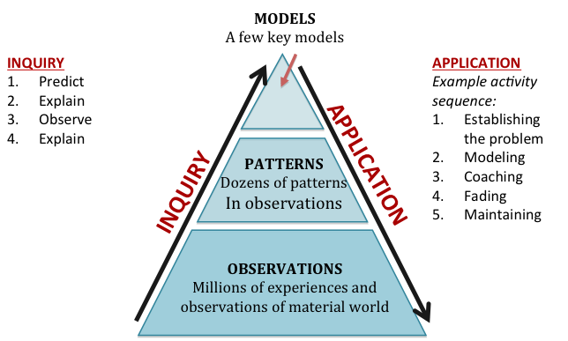
Figure 1: Inquiry and accounts activity sequences
Both activity sequences are supported by Tools for Reasoning that support goal inquiry and accounts practices. Tools for Reasoning play a key role in every unit. They support the students’ investigations by providing scaffolds for students’ predictions and explanations, encouraging but not forcing students to consider the principles above as they make predictions, explain their reasoning, and construct arguments from evidence. They support teaching of accounts by structuring the accounts in ways that make the principles visible and essential to the accounts.

Investigations: Predict, explain, observe, explain activity sequences
As Figure 1 shows, each unit has at least one core investigation. In each unit, the investigation includes a sequence of activities designed to help students master inquiry and accounts practices. The investigations will follow a basic PEOE (predict-explain-observe-explain) sequence (See Figure 1 on page 8). Typically, it will look something like this:
- Initial teaser: Students view demonstrations or videos (e.g., burning ethanol, time-lapse videos of plant growth and movement). They use the Teaser Process tool (see Appendix B) to suggest their hypotheses about answers the Three Questions for the process that they observed.
- Prediction and initial explanation: Students make predictions about (a) organisms or materials that will change mass and (b) changes in color of BTB and explain their predictions in terms of their answers to the Three Questions.
- Observation: Students measure changes in mass and observe changes in color of BTB in the system under controlled conditions.
- Revised explanation and unanswered questions: The students revise their answers to the three questions

Learning scientific accounts through cognitive apprenticeship activity sequences
Inquiry is not enough for students to master all of the accounts practices above and apply them to different carbon-transforming processes. That will require direct instruction in accounts practices. Our strategy for direct instruction relies on a cognitive apprenticeship activity sequence. For complex and difficult practices like our accounts goal practices students need to go through a process of scaffolded learning. Students can master difficult practices if they want to learn them and they have the opportunity to work on them repeatedly under different conditions.
The term cognitive apprenticeship comes from Collins, Brown, and Newman (1989), who suggest that meaningful learning of difficult practices often involves creating situations where (a) students are put in situations where they can observe other people engaging in the activity—modeling, (b) the students engage in the practice with scaffolding or support from others—coaching, and (c) the support is gradually withdrawn until the students are independently engaged in the practice—fading. These are the key middle steps of an application cycle. In addition to modeling, coaching, and fading, our version of the application cycle has two other stages. In order for modeling, coaching, and fading to be effective, students need to understand what they need to learn and to be motivated to learn—a stage that we label establishing the problem. Finally, students will forget even the best-taught knowledge and practices if they do not get a chance to encounter and use them again later, after the main teaching of the application cycle is over. This stage we call maintenance.
Each unit includes application or accounts activity sequences following a cognitive apprenticeship model. Details will vary from unit to unit, but a typical sequence might look something like this:
- Establishing the problem and initial modeling: unanswered questions
  - Unanswered questions from the investigation: Students will have unanswered questions after the investigation, particularly about the chemical identities of organic materials involved in the process they are studying
  - “Zooming in” PowerPoint slides: Students will view and discuss a series of slides that “zoom in” to the system they are studying, showing structures and movements of materials (thus answering the Movement Question) at macroscopic, cellular, and atomic-molecular scales. The final slide in this sequence shows key reactant and product molecules and poses a question: How are the atoms of [reactant molecules] rearranged to make the atoms of [product molecules]?
- Modeling and coaching: Molecular models activity and poster activity
  - Molecular models activity
    - Making reactant molecules: Students make models of reactants and put them on the reactants side of the Molecular Model Process Tool (Appendix B). They put twisty ties around high-energy (C-C or C-H) bonds. The teacher also makes a model, and there is a slide showing the reactant molecules. (For biosynthesis and digestion, monomers are represented by small molecular pictures in paper clips.)
    - Students rearrange the reactant molecules into product molecules on the product side of the Molecular Model Process Tool. All atoms and energy units (twisty ties) must be transferred from the reactant to the product side.
  - Answering the Carbon and Energy Questions: Students use the Final Process Tool and chemical equations to answer the Carbon and Energy Questions.
  - Organism Poster activity: follow-up in context. Students develop final answers to the Three Questions by tracing materials through systems on Organism Posters (see Appendix B for Mushroom Poster). They discuss what happens to reactants and products and how they are visibly manifested at the macroscopic scale (e.g., growth, movement, breathing).
- Fading: answering similar questions about other related systems (e.g., candle burning and marshmallow burning after alcohol flame; potato plant growth and radish seed growth after tree growth)
- Maintenance (connecting with other units): revisiting the process in other units and having students develop accounts of the same process in other systems (e.g., cellular respiration and biosynthesis in plants, animals, decomposers; digestion in animals and decomposers, combustion in systems and scale and human energy systems).

Teaching Support 6: Logistics
Each unit will also include the basic logistical information needed to do the unit, including a timeline and detailed lesson plans, materials for investigation and accounts activity sequences, Tools for Reasoning, videos, and student worksheets, readings, and other materials.

Summary: Helping Students Uncover the Chemical Basis for Life and Lifestyles
We are convinced that virtually all students can learn to account for the chemical changes that are responsible for the structure and functions of all living systems and support our lifestyles—carbon transforming processes. We know, though, that the key accounts and activity practices are complex and difficult. We believe students can learn them best by working their way through the levels of achievement described in our learning progression framework. It will require teaching that incorporates all of the strategies described above: taking the inquiry and accounts practices as teaching goals; formative assessment using learning progression levels; investigations; and cognitive apprenticeship activity sequences to support principle-based scientific accounts.

Appendix A: Inquiry Learning Progression Framework
Dimension 1
Levels of achievement in practices that identify and manage sources of uncertainty
- Identifying sources of uncertainty and estimating the extent of uncertainty. The “upper anchor” is a meta-level ability to critique measurements or arguments using scientific standards and vocabulary (e.g., accuracy and precision for measurement, experimental design or for arguments from evidence, peer review for collective validation).
- Engaging in practices that reduce uncertainty (e.g., making precise and accurate measurements, constructing solid arguments from evidence, identifying peer-reviewed sources for resolving scientific questions).
Levels of achievement are still to be determined, but we are close to identifying an upper anchor and lower anchor.
Dimension 2
Scale of complexity of argument: identifying and managing uncertainty in context.
There might be a basis for thinking about inquiry progressions along a scale of complexity from understanding the inquiry process to linking evidence and claims, to questioning evidence and claims in more and more complex arguments.
A. Measurement scale: classification and measurement of organic materials and organisms, plus key enablers and products of carbon-transforming processes (e.g. interpreting measurements in context of the inquiry question)
B. Investigation scale: linking evidence to claims during the investigations in our units and other similar kinds of investigations (e.g. thinking about experimental design, claims, evidence and reasoning)
C. Collective validation scale: this as a group level where collective validation occurs including processes of persuasion.
- locally (e.g., class-level validation of results of investigations) first-hand investigations
- globally (e.g., investigating ideas about what claims to trust about climate change) second-hand investigations

 | Upper Anchor | Lower Anchor
Measurement | Constantly seek new data, especially data that could falsify our current models; reject untestable models (i.e., models that fail to make predictions about things that we can’t see now.) | Firsthand experiences --- students make use of their personal and firsthand experiences to understand the world, often neglecting that there may be additional information that is important to consider. WYSIATI –what you see is all there is.
Investigation | Insist on specific questions and arguments from evidence that respond to them.  Require a rigorous search for evidence that could falsify hypotheses and a peer review system that promotes skeptical evaluation.  Favor mathematical over anecdotal evidence. | Counting an explanation of a scientific phenomenon as adequacy of evidence -- when confronted with the complex, difficult (and often statistically determined) question of how to evaluate the quality of evidence, System 1 supplies an answer to the easier, non-statistical, related question of whether or not the argument makes sense to the person evaluating it. Substituting an easier question and stories not statistics  Appeal to authority --- instead of considering whether or not a scientific argument is valid, it is easier to consider whether or not one thinks the person making the argument is qualified to do so. Some students see numerical data as authoritative regardless of whether the data support a claim.  Appeal to personal inference for example, explaining the adequacy of evidence as “I think its good because it makes logical sense and seems to be realistic to the scenario” Confirmation bias--- giving greater credence to sources, information, and arguments that agree with our personal perceptions and narratives
Validation | Require authors to establish provenance of knowledge claims that could be contested.  Encourage skepticism and peer review. | Appeal to authority  Using bias as indicating certainty of a false argument is an example of “false certainty”. If a source has a bias, such as a monetary reason to support one side of an issue, then they must be lying.  Source amnesia

Possible Dimension 3
Generality—the context of investigation or question to be addressed
The context is important and transfer of reasoning between contexts is important. This dimension has over-lay with dimension 1 and 2. For example, for overlay with dimension 2 (scale of complexity of the argument) student reasoning may play out very differently depending on whether we are investigating what happens to alcohol when it is burned (measurement), where the water in the Red Cedar River came from (investigation), or whether anthropogenic greenhouse gases are causing global climate change (validation).

Appendix B: Process Tools and Posters
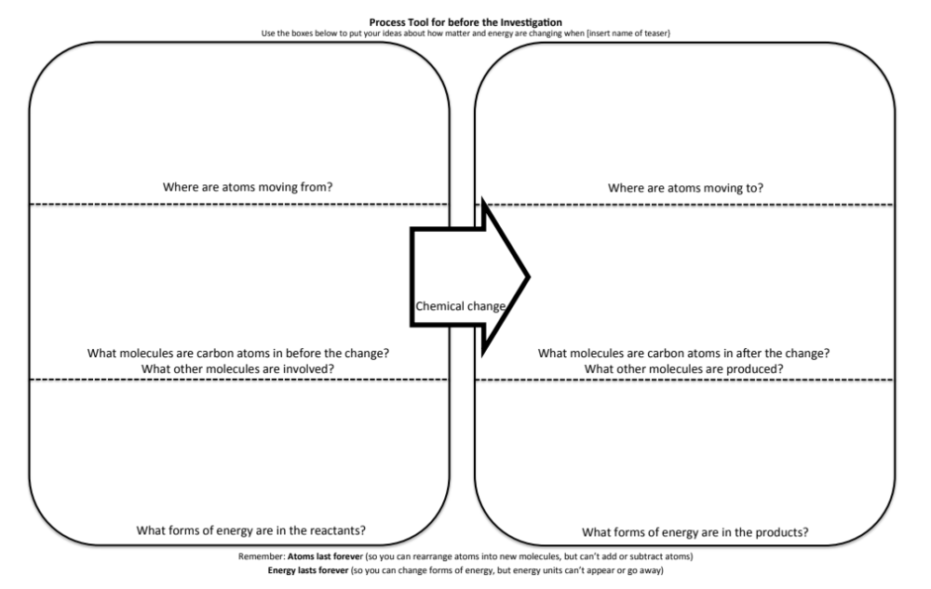
Teaser Process Tool (worksheet page and/or poster with Post-it notes)
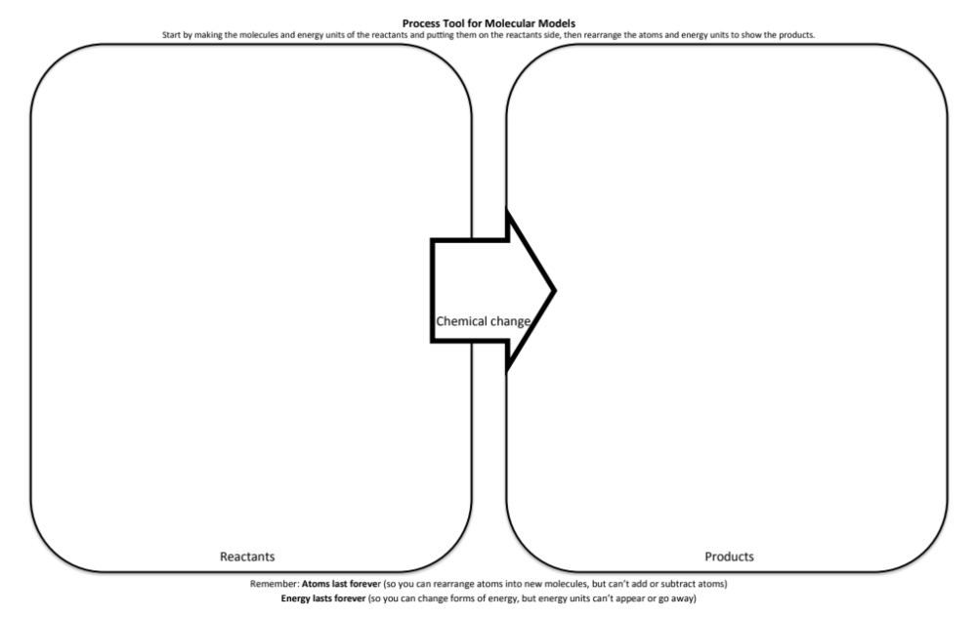
Molecular Model Process Tool (11 x 17 poster)
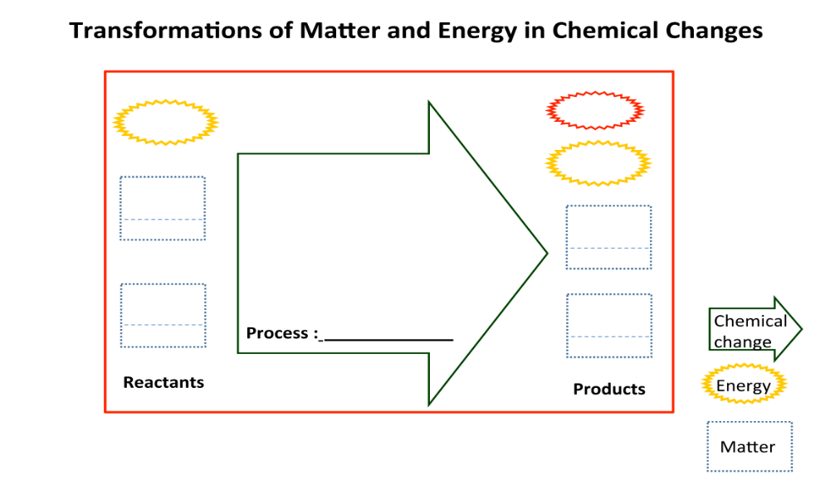
Final Process Tool (worksheet page and/or poster with Post-it notes)
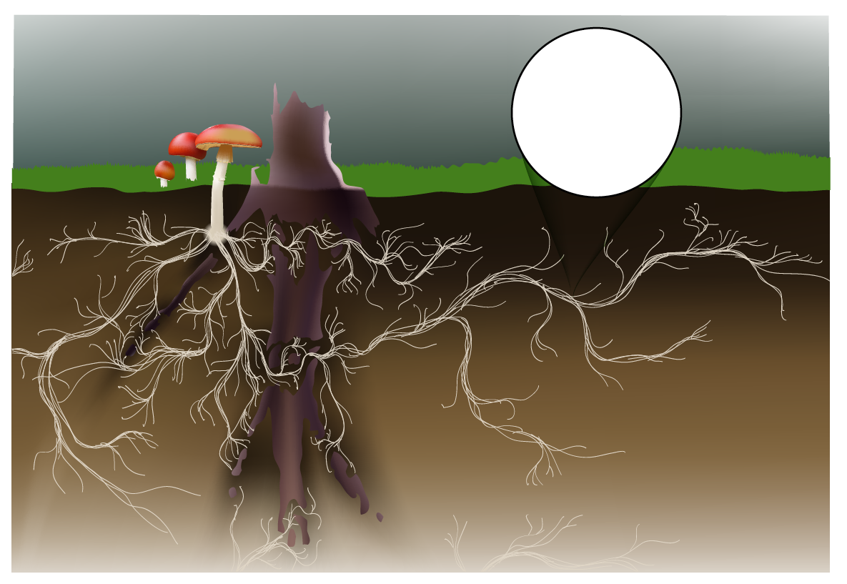
Organism Poster: Mushroom (11 x 17 poster)

This statement simplifies chemists’ understanding of the nature of chemical potential energy. It would be more accurate to say that chemical potential energy is transformed to light and molecular motion (thermal energy) when organic materials are oxidized. In the Earth’s oxidizing atmosphere, however, reduced materials that can be oxidized are the limiting reactants in most environments, and C-C and C-H bonds signal the presence of reduced carbon and hydrogen.
We are also working with the Great Lakes Bioenergy Research Center to develop a supplement to this unit focused on biofuels. Biofuels are produced by fermentation, when anaerobic decomposers like yeast partially break down complex organic molecules, but leave simpler organic molecules like ethanol. By cycling carbon between the biosphere and the atmosphere rather than adding carbon that is currently sequestered in fossil fuels,

