SYSTEMS & SCALE

ELEMENTARY SCHOOL

TEACHER GUIDE
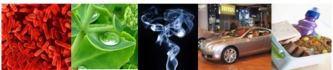

Environmental Literacy Project
http://edr1.educ.msu.edu/EnvironmentalLit/index.htm

Lindsey Mohan and Hui Jin
With help from Jonathon Schramm, Li Zhan, Kennedy Onyancha, Jim Ratcliffe, and Andy Anderson
Revised October, 2009

Development of these materials is supported in part by grants from the National Science Foundation: Developing a Research-based Learning Progression for the Role of Carbon in Environmental Systems (REC 0529636), the Center for Curriculum Materials in Science (ESI-0227557), Learning Progression on Carbon-Transforming Processes in Socio-Ecological Systems (NSF 0815993), and Targeted Partnership: Culturally relevant ecology, learning progressions and environmental literacy (NSF-0832173). Any opinions, findings, and conclusions or recommendations expressed in this material are those of the author(s) and do not necessarily reflect the views of the National Science Foundation.

Contents

Contents 2
Unit Overview and Background for Teachers: 3
Materials List: 6
Activity 1: Visible and Invisible 8
Activity 2: Powers of Ten As a Tool 12
Activity 3: Using Powers of Ten (Optional) 16
Activity 4: Materials and Needs 22
Activity 5: Investigating Air as Form of Matter 30
Activity 6: What is Energy? (Forms of Energy) 38
Activity 7: How Does Energy Change? 45
Activity 8: Energy and Fuels 52
Activity 9: Air is a Mixture 57

Unit Overview and Background for Teachers:
The Environmental Literacy Project conducts research aimed at improving the preparation of students from upper elementary through high school to act as environmentally informed citizens. A summary of our findings is available in the Introductory Guide for the carbon cycle units, More detailed descriptions of our research is available on our website: http://edr1.educ.msu.edu/EnvironmentalLit/index.htm.
One important conclusion from both our research, and our experiences in classrooms, is as follows: When students enter school, they use narratives (or stories) to explain how the world works. This is the students’ primary, or natural, discourse. The information they learn in science class teaches them more detailed narratives and new vocabulary, and they try to fit the new information into their existing narratives. Thus, students tell the same stories with more details, instead of learning new, more principled accounts about their world. The activities of this module introduce students to Tools for Reasoning that highlight important principles—tools that students will use in all of our teaching activities.

Tools for Reasoning
This unit is designed to introduce students to TOOLS FOR REASONING that embody three key principles that are essential for reasoning about environmental processes: SCALE, MATTER, and ENERGY.
- SCALE: All environmental processes occur in a hierarchy of systems at different scales; we focus in particular on atomic-molecular, microscopic, macroscopic, and landscape scales. Many students struggle to connect events that they see at the macroscopic scale to explanations at the atomic-molecular scale and to matter cycling processes at landscape and global scales. In this unit we introduce students to reasoning about scale with the Powers of 10 Tool.
- MATTER: Elementary students tend to rely on a macroscopic force-dynamic reasoning to account for events: the event involves an actor with an ability or tendency to change something internally or in their environment, using enablers from the environment to support the change (e.g., the tree uses water, air, sunlight, and soil to grow). To elementary students, this force-dynamic reasoning does not involve any exchange of matter or energy between the actor and its enablers. In this module we introduce students to reasoning about matter with the Matter and Energy Process Tool, so that changes in matter and energy become more visible to students.
- ENERGY: Elementary students may know the word energy but they usually cannot correctly identify energy involved in the events. This module introduces a list of energy forms that helps students to associate energy forms with energy evidences such as light, motion, foods, fuels, and so on. Elementary students also tend to understand energy as a type of “power” that triggers changes to occur. This type of reasoning does not account for tracing energy in and out of events. Also, elementary students usually do not recognize that heat is always released when energy transforms. In this module students use the Matter and Energy Process Tool to trace energy transformations, making energy forms more visible to students, and keeping these separate from matter.

Activities of This Module
The activities of the module introduce the core principles of scale, matter, and energy, and the Tools for Reasoning that students will use to apply those principles to systems and processes.
Activities 1-3: These activities introduce students to the idea that systems can be understood at multiple scales. An important goal for this unit is to help students gain understanding of 4 benchmark scales (atomic-molecular, microscopic, macroscopic, and landscape scale) that can help students compare the size of systems. At the elementary level, there are 3 key benchmark scales, because atomic-molecular scale is not age appropriate at this point. Students use Powers of Ten as a tool for locating and comparing systems at different scale.
- During Activity 1, students define the terms “system” and “scale” and view the Eames Brothers’ DVD on Powers of Ten. Students think about what appears and disappears as you zoom in and out of Powers of Ten. They also classify these systems in terms of the benchmark scales.
- Then Activity 2 uses a Powers of Ten PowerPoint to look closer at a more limited range of scales from 10⁸ (Earth) to 10⁻⁹ (Molecules). The teacher can use this PowerPoint to review the different Powers of Ten and to think about how the four benchmark-scales map onto the Powers of Ten.
- During the optional Activity 3, students continue to work with the Powers of Ten charts, placing more systems onto the chart and categorizing those systems in terms of the benchmark scales. Lastly, students are given an opportunity to use Powers of Ten as a tool to make specific comparisons between systems (e.g., comparing the size of a water molecule to a drop of water).
Activity 4 and 5: These are about matter.
- Activity 4 asks for students’ initial ideas about materials, and ultimately has students look at materials in terms of solids, liquids, and gases.
- During Activity 5, students engage in investigations and demonstrations that air is matter—it takes up space and has mass. They will revisit air in Activities 8 and 9 when they talk about air being a mixture of gases and organisms and flames can change this mixture.
The choice of looking at air during Activity 5 was intentional because gases are particularly problematic for students. The topic of air causes difficulties for students because air is a complex mixture of gases that are generally colorless, odorless, and thus undetectable except by indirect means. Many important phenomena, including photosynthesis, humidity, smells, pollution, and the water cycle, are associated with variations in the mixture of molecules in air. Students must learn to see air and other gases as forms of matter like liquids and solids, with all the characteristics of matter in general: -- air is made of molecules -- air takes up space. Activity 5 does not begin to cover the complexities associated with understanding gases as a form of matter, but it does introduce students to the idea that matter can be viewed at different scales AND students think about how matter can look different at one scale (macroscopic) while it is really quite similar at another (atomic-molecular).
Activity 6, 7, and 8: These three activities introduce the matter and energy process tool through three steps: introduce energy forms, introduce the energy part of the matter and energy process tool, and add the matter part of the matter and energy process tool.
- Activity 6 introduces students a list of energy forms. Based on their daily life, students have constructed a lot of ideas about energy. In their minds, energy is mostly associated with movement, activities, or life. Energy can also be a kind of semi-material which can appear and disappear mysteriously or can be converted from or into matter. All these ideas conflict with the scientific meaning of energy. In science, energy is an abstract quantity associated with certain energy evidences, such as light, sound, foods/fuels, etc. It cannot be converted from or into matter except in nuclear reactions. In this activity, we first introduce the notion of Forms of energy and a list of forms of energy is introduced with explanation about how to identify each form of energy based on its evidence.
- In Activity 7 (which can be completed in conjunction with Activity 6, students observe how several scientific toys work and figure out how energy is transformed in each event. The teacher can use the macroscopic scale Matter and Energy Process Tool and/or the “How can machine work” PowerPoint to discuss the different energy transformations. The next activity (Activity 8) will add matter transformation to the Process Tool.
- Activity 8: The purpose of Activity 8 is to use combustion as an example to introduce the Matter and Energy Process tool with both matter transformation and energy transformation. Activity 8 is also a bridge to help students connect their macroscopic experience of burning, with how materials and energy are changing. Burning is treated as a process in which fuels or air are constantly consumed by flame. Some students may recognize burning as a chemical change, but gaseous reactants or products such as carbon dioxide, oxygen, and water vapor are usually not identified. In summary, most students do not hold the idea that the materials change chemically into other materials. So, in the lab, students observe what happens when a candle burns and identify the materials (especially the gas reactant and products) involved in burning. Then use the matter and energy process tool to help them identify how both matter and energy change during burning, and the teacher uses the landscape scale process tool and/or PowerPoints to explain matter and energy transformations during combustion.
Activity 9. This is the final activity. It revisits air. Students learn that air is a mixture of gases and consider how the flame in the candle changed this mixture. They also consider how organisms (plants, animals, and decomposers) change the mixture of air. This activity serves as a bridge for examinations of metabolism and other processes in living organisms in upcoming modules.

Materials List:

Teacher Tools
Overhead projector, blank transparencies, vis a vis markers (also chart paper or chalkboard)
Computer and projector if PowerPoint.
Powers of 10 DVD
Comparing Powers of 10 Poster
Energy “Toys”
Lamp
Large Process Tool with Velcro matter/energy/process labels

Overhead Transparencies and/or Powerpoints
Visible and Invisible
Comparing Powers of 10 Overhead Transparency: Blank
Comparing Powers of 10 Overhead Transparency: Partial
Comparing Powers of 10 Overhead Transparency: Full
1 set of transparency Enabler Cards and/or 1 set of enlarged teacher Enabler Cards
Powers of Ten PowerPoint OR transparency slides of the PowerPoint
Process Tool PowerPoint for How Can Machines Work

Student Worksheets (30 total, 1 per student, students write on)
Visible and Invisible
Needs of Living Organisms
My Observations of Air
My Ideas about Energy
How Can Machines Work?
Burning A Candle
How Is Air Changed

Student Handouts for Repeated Use (30 total, 1 per student)
Comparing Powers of 10 Answer Key
Forms of energy
Air is a Mixture (and What Gases Make up Air)

Group Materials for Repeated Use (1 per group/ 8 per teacher)
Blank Powers of Ten group posters
Powers of Ten Cut-outs
Poster Putty/Scissors
Enabler Cards

Lab Materials
Aquarium or large container filled with water
2-3 clear plastic party cups
1 tissue paper
Lots of balloons
1 gym ball
1 ball pump or small air compressor
Scale sensitive to 0.1g or 0.01g (the more sensitive the better)
Fizz keeper
Empty soda bottles
Wide mouth water or juice bottles
Alka seltzers
Candle
Lighter
Large glass container or beaker

Activity 1: Visible and Invisible

General Overview:
Introduction: What does “system” and “scale” mean to you? ~ 10 minutes
Whole class: Powers of 10 video ~ 20 minutes
Whole group: Discussion of video ~ 10 minutes
Whole group: Visible and Invisible ~ 20 minutes

Estimated Time: 60 minutes

Purpose:
This lesson introduces students to the terms “system” and “scale” and also introduces students to Powers of Ten. Students at the elementary school level are likely aware of different scales, but usually have trouble connecting visible systems and processes at the macroscopic scale to less visible processes at microscopic, atomic-molecular, and landscape scales. This activity begins to teach students about 4 benchmark scales.
- The lesson begins by eliciting students’ understanding of microscopic, macroscopic, and landscape scale systems.
- The students then watch the Powers of 10 DVD (17 minutes), a video that shows the relative size of systems, from galaxies to subatomic particles. The video is approximately 17 minutes, but if time is an issue, the introductory material at the beginning of the video can be skipped (view video ahead of time to determine whether or not to use the full 17 minutes). This DVD goes far beyond the content that elementary students should be expected to know. The range elementary teachers and students should be most interested in is between 10⁻⁶ (micrometer; cells) to 10³ (kilometers) although some teachers at upper elementary may be comfortable with introducing molecules (10⁻⁹). The video should be used as a starting point for 1) introducing students to ‘scale’ as one way to compare different systems, 2) encouraging students to use the general heuristic about three benchmark scales: microscopic, macroscopic, and large-scale with a focus on the latter three, and 3) providing students with a Powers of 10 framework for comparing different systems.

Materials:
Powers of 10 DVD
Student copies of Visible and Invisible
Transparency of Visible and Invisible
Overhead projector & vis a vis markers

Advance Preparation/ Safety Considerations:
- Review Powers of 10 DVD before lesson (17 minutes) and decide how to use the DVD- as noted the DVD goes beyond the content expected of elementary kids. The teacher may want to select places to “pause” or places to fast-forward or rewind depending on what is deemed appropriate for the students.
- Gather copies of Visible and Invisible student handouts sent from MSU
- Gather copies of Visible and Invisible transparency sent from MSU

Procedures/Suggestions:
Introductory discussion: Systems and Scale ~10 minutes
- Before watching the video, it is important that students have some understanding of ‘systems’ and ‘scale’. You should spend the first 10 minutes developing a reasonable definition for these terms with your students. Some possible discussion questions and definitions include:
  - In science we look at different “systems”. What does this term mean to you? What do systems have in common that make them “systems”?
  - What does the term “scale” mean to you? What does the word “scale” mean to you? (Try to cue students to move beyond measuring scales, such as weight scales).
  - Possible definitions to use (you can use these before the video or wait until the discussion after the video, but at some point the class needs to have common working definitions for the terms ‘systems’ and ‘scale’ to use throughout the unit)
    - System: Set of connected and mutually interacting components
    - Scale: the size or range of measurement used for describing a particular system. You can use scale and measurement to compare the relative sizes of systems.

Powers of 10 video ~20 minutes
- Explain to students that they will watch a short film looking at different systems from different scales. Students might want to take mental notes of what they see in the video, however, the images will change quicker than most will be able to write notes down. The DVD can be paused to allow them to further discuss particular images, but this can also wait until later on in this module.

Visible and Invisible: What Can You See? ~10 minutes
- Pass out student handouts entitled Visible and invisible. Read the instructions with students and tell students that the list of things at the beginning of the worksheet represent different systems or components of systems that were included in the video. Tell them that one way of thinking about scale is to group things in terms of 4 broad categories. These include atomic-molecular (things that are too small for even a powerful microscope to see), microscopic/cellular (we cannot see but can use a microscope to see), macroscopic (things we can see with our eyes), and landscape scale (things that are too large to see with our eyes, but we can use representations and models to see). Encourage the students to dissect the words, for example, discussing what “scopic”, “micro”, and “macro” means and developing a set of working definitions for each of these benchmark scales. Tell students to look through the list on their handout and think about the video. Then have the students classify each system or component into 1 of the 4 broad benchmark categories.

Reflective Discussion: Systems and Scale ~10 minutes
- The reflective discussion can take a variety of forms depending on the available class time. NOTE: You will only need page 1 of the student handout unless you plan to watch the Powers of Ten video again. If time is short, focus the discussion on how students categorized the various systems on page 1 of Visible and invisible and any discrepancies or disagreements they may have. Try to come to consensus about how to categorize the list of systems in terms of the benchmarks, and continue to review the benchmarks with students. If there is enough time remaining during the class period, consider watching the Powers of 10 video again, and review the zooming in and out table as a class, by pausing at each Power of 10. What appears and what disappears? Let students use Page 2 of handout if necessary. As you pause the DVD, ask students, “which of the 4 broad categories does each system belong to: atomic-molecule, microscopic, macroscopic or landscape scale.” Again, focus the discussion on discrepancies and try to reconcile them by asking questions such as “Can we see it with our eyes? Can we see it with a microscope?”

NOTE: In Activity 2 you will continue to build on the 3 key benchmarks for scale (microscopic, macroscopic, and landscape scale) using Powers of Ten to locate things on the scale. Mostly, this activity includes modeling of Powers of Ten by the teacher, and manipulation of a few key objects on a chart. During Activity 3 students will have a chance to manipulate and use Powers of 10.
Name: _____________________________________ Date: ________________

Visible and Invisible
When thinking about different scales, we can generally group systems and parts of systems into one of three groups: 1) microscopic/cellular (we cannot see with our eyes, but can use a microscope to see), 2) macroscopic (things we can see with our eyes), and 3) landscape scale (things that are too large to see with our eyes).
With your classmates, try to think of all the things that may be too small or too large to see with the human eye, and things that can be seen with the human eye. Try to list the things into one of the three categories in the Table below.
TOO SMALL TO SEE WITH HUMAN EYE  (microscopic and smaller) | CAN SEE WITH OUR EYES  (macroscopic, visible) | TOO LARGE TO SEE WITH HUMAN EYE  (Landscape scale)
DNA  Cells (white blood cells; skin cells)  Atoms  Molecules  Bacteria  Air (molecules)  Other possibilities | Skin  Body and body parts  Plants  Animals  Cars  School bus  Paper  Pencil  Chair; Furniture  Food  Other possibilities | Earth  Solar systems  Galaxies  Large Ecosystems  Big Cities  Other possibilities

Questions:
- How are really small things part of the visible things we see with our eyes?
Small things make up the things we see

- How are really large things connected to the visible things we see with our eyes?
All things are connected in systems, like ecosystems or earth systems. All the things we see make up the large systems

Activity 2: Powers of Ten As a Tool

General Overview:
Introduction to Powers of Ten PowerPoint ~ 20 minutes
Mapping Benchmark Scales onto Powers of Ten Chart ~ 10 minutes
Powers of Ten Chart and Practice placing Items ~ 20 minutes

Estimated Time: 50 minutes

Purpose:
The students have watched the Powers of 10 DVD, a video that shows the relative size of systems, from galaxies to subatomic particles. They have also learned definitions for the words “systems” and “scale” and learned about 3-4 benchmark scales: atomic-molecular, microscopic, macroscopic, and landscape scale. In this second lesson, the Powers of 10 chart will be used as a framework for comparing systems at different scales, for example, comparing the size of molecules to cells and cells to leaves, etc. The teacher will first use a set of PowerPoint slides to bridge what students saw in the Powers of Ten video to using Powers of Ten as a comparative tool. The Powers of Ten PowerPoint slides zoom in and out from Earth to molecules. Then students practice mapping benchmark scales to the Powers of Ten chart, and they will also begin mapping systems to charts. The goal of this lesson is to give students more practice with understanding scale and to help students see how Powers of Ten and the benchmark scales are both useful ways of comparing systems.

Materials:
Power of Ten (New).ppt (PowerPoint) Or overhead transparencies of the ppt slides
Computer and projector OR overhead set and overhead projector
Comparing Powers of 10 Overhead Transparency: Blank (from master)
Comparing Powers of 10 Overhead Transparency: Partial answers (from master)
Blank Powers of Ten group posters
Small set of Powers of Ten cut-outs
Overhead projector & vis a vis marker

Advance Preparation: If Not Completed by MSU
- View Powers of Ten (New) PowerPoint and practice projecting this PowerPoint in classroom OR make overhead copies of each slide to use on overhead/opaque projector.
- Gather overheads for Comparing Powers of 10 (blank, partial)
- Gather poster-size copies of Comparing Powers of 10 Group Chart (blank) for each group
- Gather color copies of Comparing Powers of 10 Cutouts (students will only use a small set of these today, but will use all of them during Activity 3)

Procedures:
Introduce Powers of Ten using PowerPoint slides ~20 minutes
- A PowerPoint slideshow has been developed as a way of bridging the Powers of Ten DVD viewed during Activity 1 with the Powers of Ten charts that are used in Activities 2 and 3 and throughout other classroom activities. The PowerPoint allows the teacher and students to zoom in and out at various steps similar to the DVD. This format allows the teacher to go step by step through various systems and scales and talk about the size of the system (and start making comparisons to other systems). There are two ways to use the PowerPoint slides: Either on a computer projected to the class or by printing off overheads of the PowerPoint slides and showing them on an overhead projector. The PowerPoint corresponds with many images of the Powers of Ten DVD but some images have also been replaced.
- First, have students review what they learned about systems and scale from Activity 1. Also ask students to share what they learned about the three key benchmark scales. Remember that students may also talk about atomic-molecular scale as a 4th benchmark scale.
- Then use the PowerPoint slides to teach about systems and scale. For each slide, first ask students what the system is (i.e., a solar system, planet, flower, virus, etc). Ask students what benchmark scale the system belongs to (i.e., atomic-molecular, microscopic, macroscopic, or landscape scale). As you get to the most familiar systems (Earth, cities, flowers, cells, virus, DNA), start modeling how to use the Powers of Ten to compare systems. These comparisons may be difficult for students, particularly those who struggle with math. As you model comparisons, pick examples from the familiar objects. For example, you might say, “A virus is 1 micrometer, but bacteria are 10 micrometers. That means bacteria are roughly 10 times larger than viruses”.
- While the most important goal for elementary school students is to have them learn and use the key benchmark scales, the Powers of Ten can also be a useful tool for comparisons. At this age level, consider focusing on the most familiar scale comparisons (i.e., systems at a meter are 100 times larger than systems at a centimeter, systems at a centimeter are 10 times larger than something at a millimeter, etc). Stay within the range of cells to meters.

Introducing Powers of Ten Chart ~25 minutes
- Introduce the “horizontal” powers of ten charts to students using the blank Powers of Ten overhead transparency. Explain that this new chart is a second way of representing the Powers of Ten chart and make comparisons to PowerPoint slides. At this time, consider mapping the PowerPoint systems on the chart to bridge what students learned in the PowerPoint slides to what they will be doing next with the powers of ten charts. Use a wet erase pen to write these items on your blank powers of ten overheads.
- As you map items from the PowerPoint to the chart, explain the axis on the chart and how to use Powers of 10. Although students may be familiar with powers of 10, they may not realize how to use it to compare the size of objects. One idea to emphasize here is that when you are comparing across such a wide range of scales, you don't need to know exact sizes of objects- that the powers of ten are helpful in making estimates about sizes and differences in scale.
- Now that several items from the PowerPoint are mapped onto the blank powers of ten overhead transparency, allow students to continue this mapping using a select group of “systems” found in the Powers of Ten cut-outs. Pass out the blank Powers of ten poster charts to groups of students. Ideal group sizes would be 3 (but no more than 4 students). Pass out a set of powers of ten cutouts (listed below). Engage students in using Powers of 10 by asking them to predict the location of those systems on the chart:
  - the length of an average school bus
  - the length of a passenger car
  - a rain drop
  - a sand particle
  - a particle of milled flour
  - particulate pollution (smog)
  - a plant stomata
- Give students about 8-10 minutes to discuss these objects/systems and place them on the charts. Then, as a whole class, mark student responses on the blank transparency using the vis a vis marker (similar to making the systems from the powers of ten PowerPoint).
- Then display the overhead transparency that shows the position of these items on the Powers of Ten Chart (this is the ‘partial’ overhead). Discuss differences in student responses, focusing on why they thought an object was larger or smaller than it actually is.

Whole class: Comparing Powers of Ten to Benchmark scales ~15 minutes
- At this point students need to map the benchmarks onto the poster. Using the partial powers of ten overhead, have the students decide which powers of ten fall into each scale benchmark. The following are suggestions for how to divide the chart into benchmarks:
- Atomic-molecular (10⁻⁹)
- Microscopic (10⁻⁸ through 10⁻⁶)
- Macroscopic (10⁻⁵ through 10²)
- Landscape Scale (10³ through 10⁵)

Also point out the familiar measurements to students again: millimeter, centimeter, meter, and kilometer.
Collect the group charts and cut-outs to be used during Activity 3

Activity 3: Using Powers of Ten (Optional)

General Overview:
Whole class: Explaining & Modeling Powers of 10 ~ 20 minutes
Student groups: Completing Comparing Powers of 10 Group Chart ~ 20 minutes
Whole class: Checking the Comparing Powers of 10 Group Chart ~ 20 minutes

Alternative:
Whole class: Explaining & Modeling Powers of 10 ~ 20 minutes
Whole class: Completing Comparing Powers of 10 Chart ~ 30 minutes

Estimated Time: 50-60 minutes

Purpose:
The students have watched the Powers of Ten DVD, a video that shows the relative size of systems, and they have developed general categories for “Microscopic or smaller”, Macroscopic”, and “Landscape Scale”. In this lesson, the Powers of Ten chart will be used as a framework for comparing things at different scales, for example, comparing the size of cells to leaves, etc. The teacher will first model for students how to use Powers of Ten to make comparisons between systems. The teacher can then decide to complete the Powers of Ten activity in small groups or as a whole class. If small groups are chosen, students will work in groups/partners ‘predicting’ where certain objects and systems fit on a poster-size Powers of 10 chart. They will cut out photos of the different objects and tape/stick them to the poster-size chart. The class will then talk about where certain things were placed. If the teacher selects to complete the activity as a whole class, the teacher will have students help place “cut-outs” onto a Powers of Ten chart, and then the class will discuss how to use the chart. The teacher will give students a regular sized copy of the actual Powers of 10 chart for students to have and use (or keep these in the classroom to be used throughout the year).

Materials:
Comparing Powers of 10 Overhead Transparency: Blank
Comparing Powers of 10 Overhead Transparency: Partial
Comparing Powers of 10 Overhead Transparency: Full
Student copies of Comparing Powers of 10 Answer Key
Student or Class copy of Comparing Powers of 10 Group Chart (1 per group or 1 per class)
Student or Class copy of Comparing Powers of 10 Cutouts (1 per group or 1 per class)
Poster Putty/Scissors
Overhead projector & vis a vis marker

Advance Preparation/ Safety Considerations:
Gather overheads for Comparing Powers of 10 (blank, partial, answers) sent from MSU
Gather copies of Comparing Powers of 10 Answer Key sent from MSU
Gather poster-size copies of Comparing Powers of 10 Group Chart (1 per group or 1 per class) sent from MSU
Gather color copies of Comparing Powers of 10 Cutouts (1 per group or1 per class) sent from MSU
Gather color vinyl poster of Powers of 10 sent by MSU

Procedures/Suggestions:
Explaining & Modeling Powers of 10 ~20 minutes

- Spend about 5 minutes reviewing the previous lessons on Powers of Ten and the 3 general categories students developed to describe the size of different things. Tell students that these three categories are useful, but they don’t let you make specific comparison between different systems, or different things. For example, both a mosquito and a car would be in the “macroscopic” category, but they are very different sizes.
- Introduce students to the Powers of 10 chart using the Comparing Powers of 10 Overhead Transparency (blank). Explain the axis on the chart and how to use Powers of 10. Show students the different measurements, such as centimeters, kilometers, meters, etc. Ask them “how many centimeters are in 1 meter? Then demonstrate for students how to use each vertical line as a “times by 10” rules. So if students compare the centimeter line to the meter line they have to make two “hops” (from 10⁻² to 10⁻¹ and then 10⁻¹ to 10⁰). Each time they “hop” or cross over a line, they need to times by 10. A meter is 100 times the length of a centimeter. Provide students with enough instruction so that they understand how to use the lines to compare sizes. Go through as many examples as necessary.
- The teacher will also need to explain “ranges” for objects. Cells, for example have a range 1 micrometer to 100 micrometer (these are divided into bacterial cells and plants and animals cells).
- In order to practice with students, use the “partial overhead” as a starting point. Have the students first “predict” the location of the Partial overhead objects before showing it to them. These include:
  - the length of an average school bus
  - the length of a passenger car
  - gravel
  - human hair
  - a particle of milled flour
  - plant and animal cells
  - carbon dioxide molecule
- Mark their predictions on the “blank overhead”. Then, overlay the partial overhead onto the blank and look at how students’ comparisons matched with the actual chart. Discuss student responses, focusing on why they thought an object was larger or smaller than it actually is. If time, have students practice making a few comparisons between the objects on the partial overhead.

OPTION 1
Group work: Comparing Powers of 10 Group Chart & Cut-outs ~20 minutes

- Then pass out poster-size copies of Comparing Powers of 10 Group Chart (1 per group) and color copies of the Comparing Powers of 10 Cutouts (1 per group) and scissors/tape. Students should cut out the labeled pictures from the cutout pages. Have students place the items from your discussion above (items a-g) on their chart first. The students are to arrange the remaining cutouts on their Comparing Powers of 10 Group Chart for 15 minutes and tape down the pictures. The goal for student groups is that they have an opportunity to predict the size of certain objects, especially in relation to other objects. These are only predictions, which will be followed by discussion of the actual placement of each object.

Whole Class-Discussion of Poster-Size charts ~20 minutes

- As a class, students should come to a consensus—with the teacher’s guidance—in regard to the positioning of the items on the Powers of 10 chart. At this time, the teacher may show students an overhead copy of the actual placement of objects and pass out student copies of Comparing Powers of 10 Answer Key. Then have student groups compare and contrast their poster-size charts with the ‘answer key’ and talk about objects that they misplaced or objects that were easier to place than others.
- Introducing Powers of Ten representation (optional): What appears and disappears when moving across different scales and systems? An additional representation of Powers of Ten has been provided and can be used to for students to think carefully about what appears and disappears when zooming in or out.

OPTION 2 ~30 minutes

- Hang a blank poster of Comparing Powers of 10 Group Chart and gather the color copies of the Comparing Powers of 10 Cutouts. As a class, think about where these images belong on the chart. Have students place the items from your discussion above (items a-g) on their chart first. Then continue to place the remaining items on the chart. The goal is that they have an opportunity to predict the size of certain objects, especially in relation to other objects. These are only predictions, which will be followed by discussion of the actual placement of each object.
- As a class, students should come to a consensus—with the teacher’s guidance—in regard to the positioning of the items on the Powers of 10 chart. After students have predicted locations, the teacher should share actual locations of the items. Discussion should follow with regards to items that were surprisingly smaller or larger than expected.

Alternative or Additional Representation

- What appears and disappears when moving across different scales and systems? An additional representation of Powers of Ten has been provided and can be used to for students to think carefully about what appears and disappears when zooming in or out. This can be printed as an overhead and the class can go through the overhead step-by-step as an alternative representation.
Blank Overhead and Blank Posters for Students:
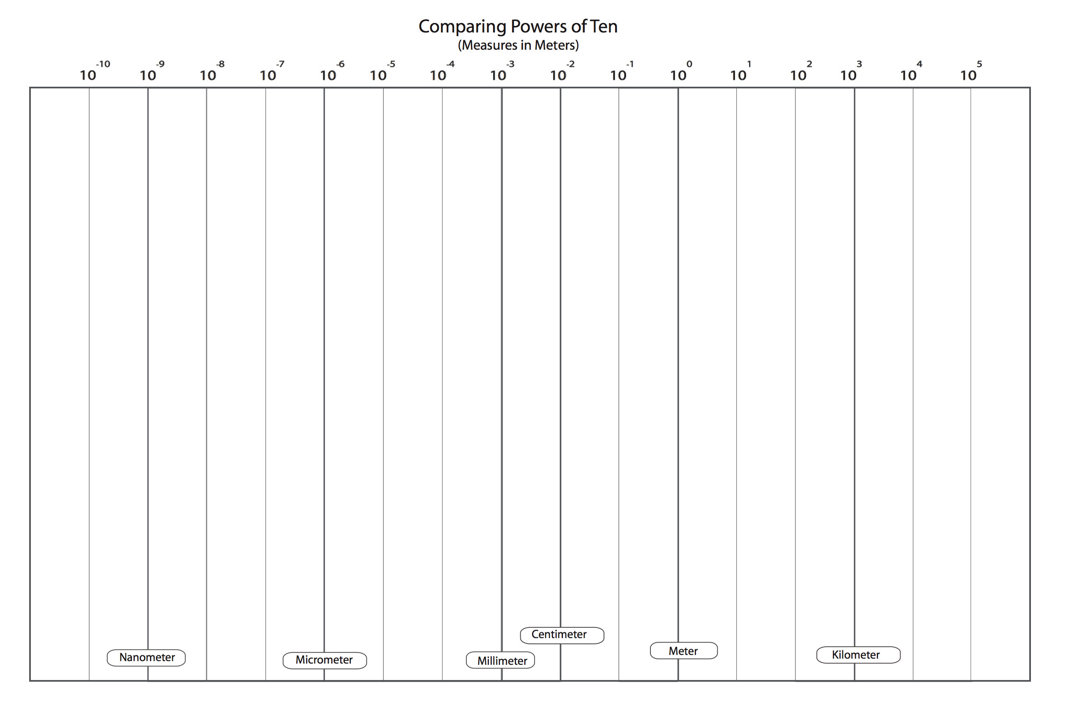

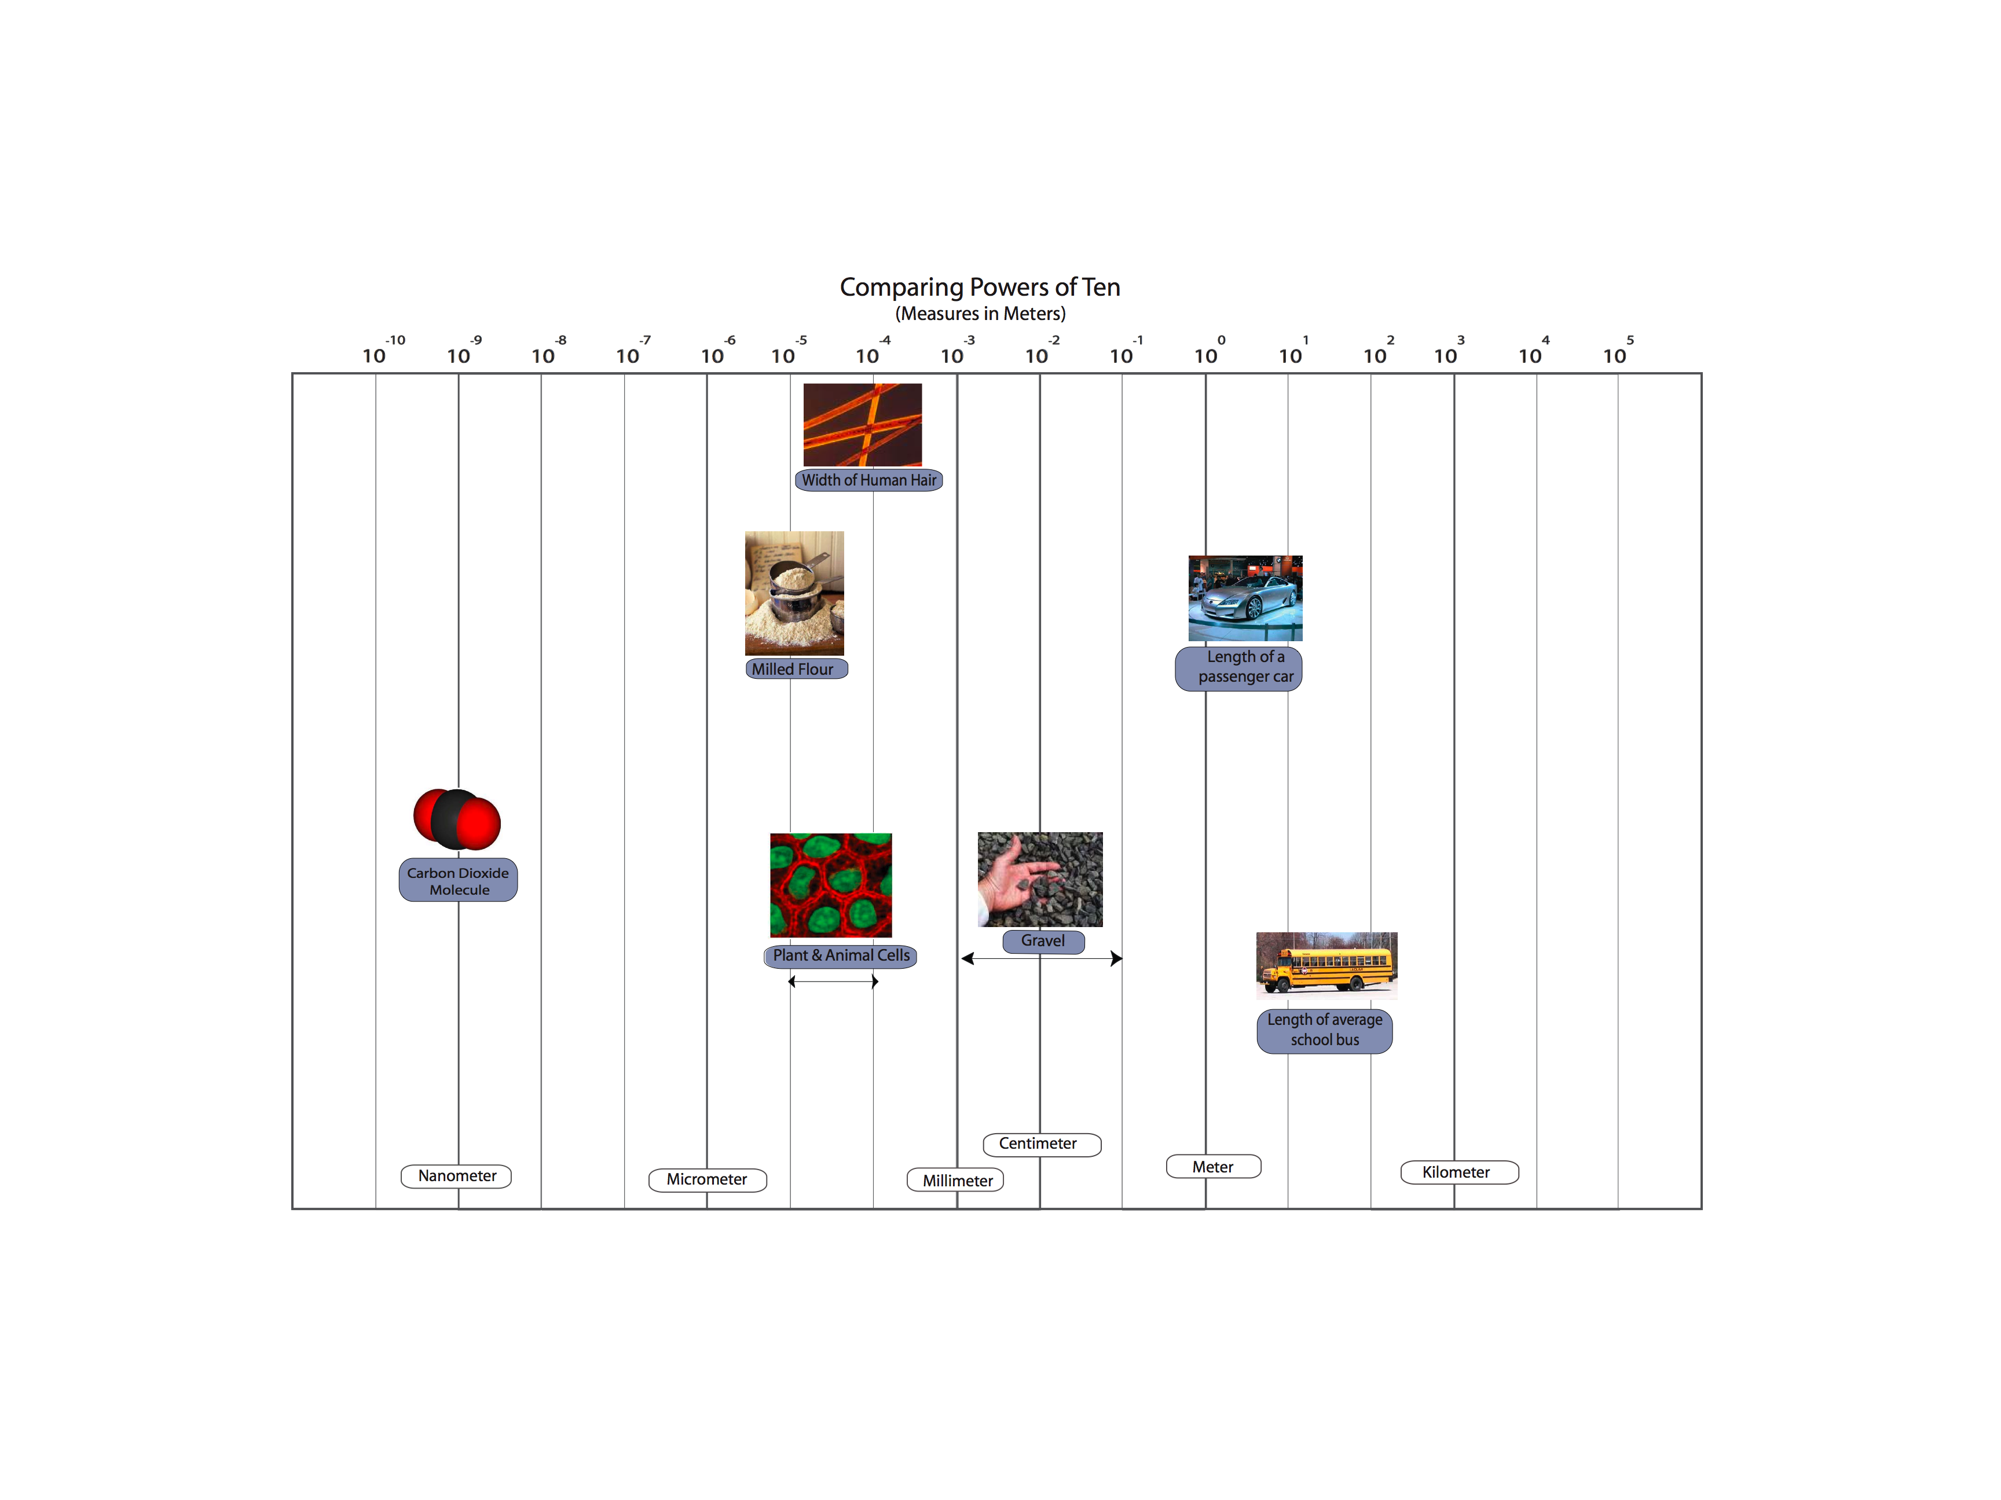
Partial Overhead:
Complete Powers of Ten: Vinyl Class Poster, Student “Answer Keys”, Complete overhead
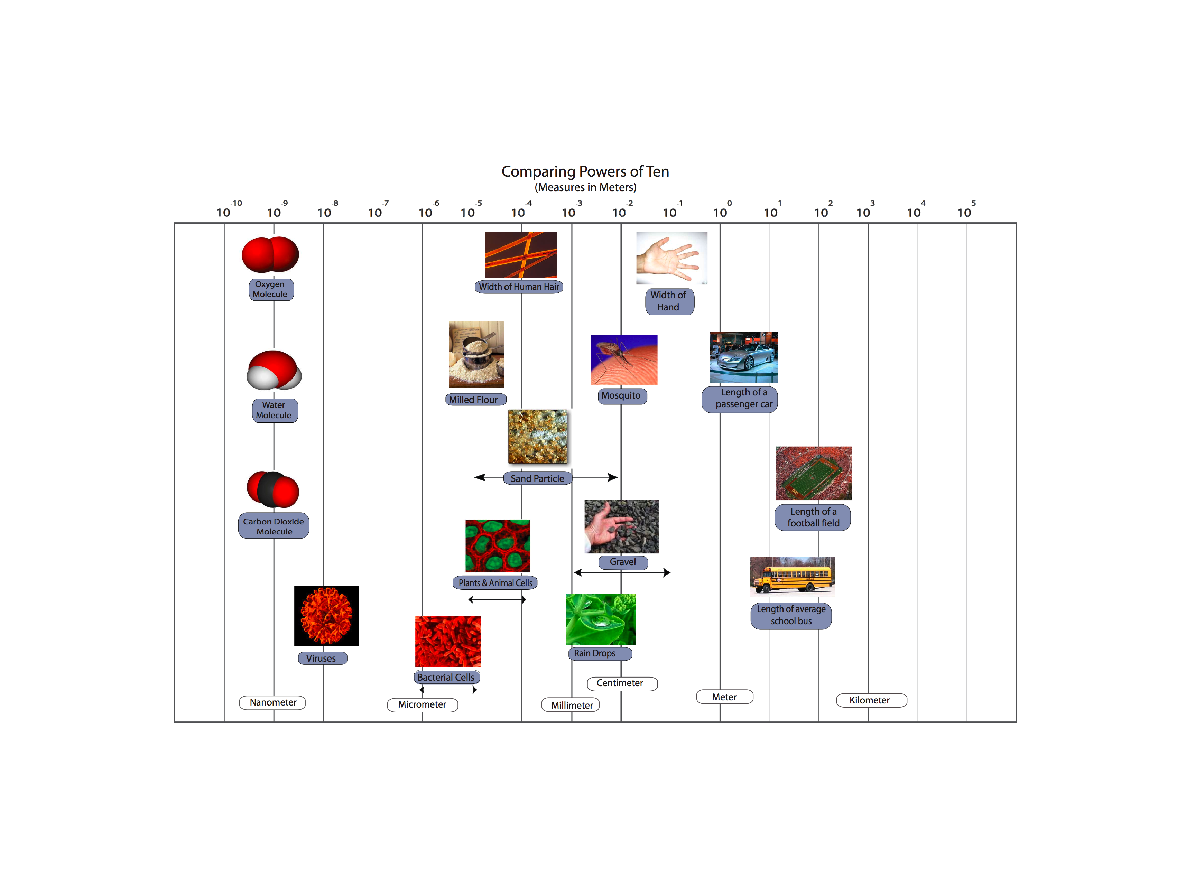

Activity 4: Materials and Needs

General Overview:
Initial Card Sorting Task ~20 minutes
Card Sorting of Needs ~15 minutes
Living organisms and Needs ~15 minutes

Total Time: 50 minutes

Purpose:
You can make the transition from Powers of Ten, by explaining to students that they now will learn more about the molecules at the atomic-molecular scale, which means we cannot see them with our eyes and we cannot see them with a microscope.
This activity is intended to get students thinking about material states—solid, liquid, and gas—to develop students’ ideas about matter. This is the first introduction of matter in this unit. It is also a chance to explicitly teach about gases, which are particularly problematic for students. It provides an opportunity to establish a shared definition of matter in terms of its macroscopic characteristics—that matter takes up space and that it has mass (or weight for this age level).
Students sort cards of different materials/non-materials in several different ways and share how they “categorized” those materials/non-materials. Then the teacher has students sort explicitly in terms of matter/material versus non-matter/non-material. This gives the teacher a chance to talk about why “warmth” and “exercise” are not the same as other enablers, such as food, water, and air. It is also the first time to explicitly say that “air” is matter. Students then sort the matter cards into solids, liquids and gases. At the end, students have a chance to share their ideas about how living organisms are similar and different in the way they use materials and non-materials.

Materials:
Student copies of Needs of Living Organisms
10 sets of Enabler Cards for students---materials and needs:
Each contains; bread, fruits/veggies, milk, juice, water, air, warmth, exercise, gasoline, sand and rock
1 set of transparency Enabler Cards and/or 1 set of enlarged teacher Enabler Cards
Chart Paper or Blank transparencies (or chalkboard) to record students’ card sorting task

Advance Preparation/ Safety Considerations:
- Have/make copies of Needs of Living Organisms
- Gather Enabler Card packets for student groups
- Gather Teacher’s transparency Enabler cards and/or enlarged Enabler cards
- Gather chart Paper or Blank transparencies (or chalkboard) to record students’ card sorting task

Procedures/Suggestions:
Initial Card Sorting Task ~20 minutes
- Tell students that today they will continue to learn about different material needs, but that they are going to use those ideas to explore the characteristics of air.
- Distribute a packet of cards to each pair or small group of students. Have students sort their cards into 2-3 groups---they may choose to sort the cards as 1) solids, liquids, and gases, OR 2) foods and everything that is not food, OR 3) things people need to live and things that we don’t need to live, OR 4) things that were once alive and things that are not alive, OR 5) things that are matter and things that are non-matter, etc. Once groups sort their cards, have each group share how they decided to sort the cards. Use the color overhead transparency cards, or an extra set of cardstock cards to demonstrate the sorting of each group. As groups share, record all the different ways that the materials were sorted.

Card Sorting Task #1: Enablers ~15 minutes
- Now hold up the following eight cards: bread, fruits/veggies, milk, juice, water, air, warmth, and exercise. Tell students these are things people need to stay alive. Ask students how each “need” helps people stay alive? Then ask which of the things belong to matter and which are something else.
Matter: bread, fruits/veggies, milk, juice, water, air
Non-matter: warmth, exercise, sunlight
- As students group the “needs” in terms of matter and non-matter, help the class develop an understanding of matter as anything that takes up space and has mass (weight can be used as an alternative to mass). The key idea at this point is that sunlight, warmth and exercise are Non-matter, while air IS matter. At this point, the cards can be divided into two groups: Matter and Non-Matter. Before proceeding, make sure all students have these grouped in terms of how the class reached consensus. It is possible that air will still be questioned by students.
- Divide the matter cards into three groups, using solid, liquid and gas to organize the groups. Don’t tell students that you organized the cards this way. Instead, ask students, “Look at the new way I grouped all the things that were matter. Do you notice a pattern? Can you think of a name that describes each group?” Help students generate “solid”, “liquid” and “gas” to describe each type of matter.
Solid: Bread, fruit/veggies
Liquid: Milk, juice, water
Gas: Air
- Then, ask students, “Do bread and fruit take up space? Do they weigh something? So are they matter?” Ask the same questions for liquids and gases. STUDENTS MAY NOT AGREE THAT GASES ARE MATTER SO TELL THEM THAT THEY WILL LEARN MORE ABOUT THIS IN THE NEXT LESSONS.

NOTE: There are 2 “AIR” Cards

Think-Pair-Share: Needs and Organisms ~15 minutes
- Pass out Needs of Living Organisms worksheet. Tell students that they are going to answer questions about how living organisms meet their needs. They will first think about and write their ideas to these questions on their own. After 5 minutes, they will share their ideas with a partner, and revise what they have written (if necessary). Then the students will share their responses during a whole class discussion.
- Students will first list what they believe each organism needs. Then, they classify this list in terms of matter (solid, liquid, gas) and non-matter.
- The goal of this exercise is for students to consider both the Matter and Non-matter needs of all organisms. Students should see that all organisms need food, air, and water- these are forms of matter that help organisms grow. Students may not recognize that organisms need gases and they may be challenged by deciding on which things belong to matter or which ones belong to non-matter.


Juice

Fruits and Vegetables


Air Picture #1


Milk


Gasoline

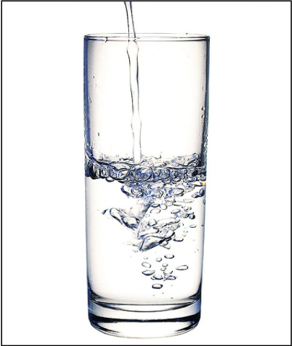
Water
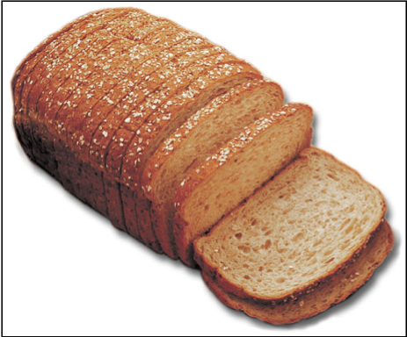
Bread

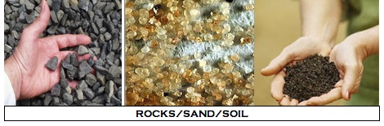

MATTER

NON-MATTER

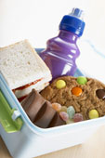
FOOD

WARMTH


EXERCISE


Air Picture #2


Sunlight

Gas
Solid
Liquid
Name: ____________________________________ Date: ________________

Needs of Living Organisms
Living organisms include plants, and animals some of which are decomposers. In order to stay alive, organisms must meet their daily needs. Think about what living things need, and then answer the questions below.
PLANTS
- What things do plants need to live and grow? List all the things that plants need.

Students may list: Water, soil, sunlight, nutrients, air or carbon dioxide. They may also list things like space, love, and shelter.
Look at your list above. Decide whether each thing you listed is matter or is non-matter and then place it where it belongs in the table below.
Matter |  |  | Non-matter
Solid | Liquid | Gas
Soil & nutrients in soil | Water | Air or carbon dioxide and oxygen | Sunlight  Shelter, space

ANIMALS
- What things do animals (including people) need to live and grow? List all the things that animals need.
Students may list things like: food, air or oxygen, exercise, vitamins, water ________________________
____________________________________________________________________________________________________________________________________________________________________________________________________________________________________________________________
Look at your list above. Decide whether each thing is matter or is non-matter and then place it where it belongs in the table below.
Matter |  |  | Non-matter
Solid | Liquid | Gas
Food  Vitamins | Water | Air, Oxygen | Exercise

DECOMPOSERS
- What things do decomposers need to live and grow? List all the things that decomposers need.

Students may list a variety of things: Soil, compost, dead things, food, air, shelter or a place to live, sunlight, heat, and moisture._____________________________________________________________
____________________________________________________________________________________
Look at your list above. Decide whether each thing is matter or is non-matter and then place it where it belongs in the table below.
Matter |  |  | Non-matter
Solid | Liquid | Gas
Soil,  Dead Tree or other dead things  Compost materials  Food | Moisture | Air | Shelter  Heat  Sunlight

NOTE: Answers are just suggestions, not right or wrong answers

Activity 5: Investigating Air as Form of Matter

General Overview:
Generating Matter List ~15 minutes
Air Investigations ~25 minutes
Share and Discuss Observations ~15 minutes
Total Time: 50 minutes

Purpose:
Problems students may have: We speak of air as light, "airy," “insubstantial”, or even as “nothing.” The topic of air causes difficulties for students because air is a complex mixture of gases that are generally colorless, odorless, and thus undetectable except by indirect means. Many important phenomena, including respiration, photosynthesis, humidity, smells, pollution, and the water cycle, are associated with variations in the mixture of molecules in air. Students must learn to see air and other gases as forms of matter like liquids and solids, with all the characteristics of matter in general: -- air is made of molecules -- air takes up space – air has mass or weight. The next two activities focus specifically on helping students understand gases as a form of matter.
Activity 5 includes observable investigations that show air has the same macroscopic characteristics of solids and liquids—that air takes up space and has mass. These investigations can be conducted as demonstrations by the teacher and/or students or as rotating lab stations. In order to focus the class discussions around the investigations (and to ensure that students get the most out of each investigation) we recommend that you conduct whole group demonstrations. However, some can be completed by all the students (e.g., blowing up a balloon, alka seltzer and balloon).
The point of today’s activity is to talk about macroscopic observations that tell us air takes up space and has mass, and to consider how air may contribute to weight loss or weight gain.
The following activity goes into more detail about what makes up air (air as a mixture of gases) and how agents change the air around them.

Materials
Student copies My Observations of Air
1 set of overhead transparency Enabler Cards and/or 1 set of enlarged Enabler Cards
Chart Paper or Blank transparencies (or chalkboard) to record students’ Matter-Non-matter List Investigation supplies:
- Aquarium or large container filled with water
- 2-3 clear plastic party cups
- 1 tissue
- Lots of balloons
- 1 gym ball
- 1 ball pump or small air compressor
- Scale sensitive to 0.1g or 0.01g (the more sensitive the better)
- Fizz keeper
- Empty soda bottle
- Alka seltzers
- Wide mouth juice or water bottles

Advance Preparation/ Safety Considerations:
Gather transparency Enabler cards and/or enlarged Enabler cards
Gather chart Paper or Blank transparencies (or chalkboard)
Have student worksheets My Observations of Air
Investigations: Investigations 4, 5, 6 and 7 a head of time to check that your scale is sensitive enough to detect a difference in mass or weight. Also check the alka seltzer demonstrations for time it takes to dissolve and to know how much pressure will build up inside the balloon or container.

Procedures/Suggestions:
Generating Matter List ~15 minutes
- Show students the three groups of cards from Activity 6-these show solids, liquids and gases. Remind students that they were talking about two groups of things: those that are matter and those that are non-matter. Ask students if they remember how we define or describe matter (a material that takes up space and has weight/mass). Write this on the front board or overhead. Then take out the Matter overhead transparency or use chart paper to record students’ ideas about things that are matter and those that are non-matter.
- First list things (that are matter) in the matter column. Then, ask students about things that are non-matter and write down their ideas. There may be overlap between the columns. If overlap occurs, circle or highlight those items.
The table below shows an example of a list of students’ ideas of matter and non-matter items generated by a 4th/5th grade class. This may show similar items that students will share during this activity. Note that students were still confused about whether things like air, gases, heat and clouds were matter.
MATTER | NON-MATTER
Furniture (Bed)  Plants  Building, School  Refrigerator  Anchor  Air  Heat  Living things  Water  Animals  Body parts, People  Boulders, rocks  Books  Machines  Walls  Metals  Clouds  Playground | Light  Chemical gases  Carbon dioxide  Shadows  Sound  Electricity  Heat  Clouds  Germs  Gravity  Imagination  Air  Ants  Water vapor

Tell students that today they are going to look closer at gases and decide if it meets the definition for matter. Does gas take up space? Does gas have mass?

Air Investigations ~25 minutes
- There are several possible ways to conduct the following investigations. The teacher can gather students around the front of the room and demonstrate each one, while students record observations OR students can rotate through several stations, conducting the investigations and recording observations, then sharing with the whole group later. We recommend conducting demonstrations in order to focus students’ attention and discussion on individual investigations. The decision also depends on available supplies.
- Pass out My Observations of Air to each student.
- Proceed with the investigations and make sure to focus discussions of the investigations on what they demonstrate- that air takes up space and has mass (which at the macroscopic scale is similar to solids and liquids).

Investigation #1: Move Air Under Water
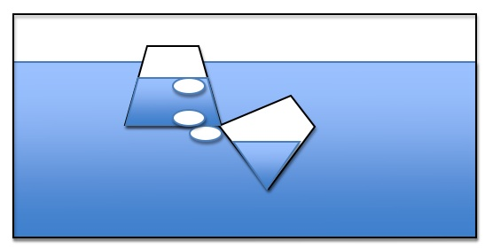
This investigation is a simple demonstration to transfer air between two submerged cups. Fill an aquarium or large, transparent container with water. Use 2 small plastic cups for the demonstration. As you submerge the cups, make sure one fills with water, while the other captures mostly air. Place the cup with the air tilted underneath the cup with water and slowly move the air back-air-forth between the cups. Ask students if the air or air bubbles take up space.


Investigation #2: Keep a Napkin Dry Under Water
This investigation is a simple investigation to show that a napkin can stay dry under water. Take a tissue/napkin into the bottom of a clear cup. Fill an aquarium or large container with water. Flip the cup so that it is facing down. Carefully submerge the cup trapping air inside the cup as it enters the water. Be careful not to tilt the cup because this may release water. Slowly bring the cup out of the water. Let students feel the napkin to verify that it is still dry. Ask students if this shows that air takes up space.

Investigation #3: Blow-Up a Balloon

Tell students to blow up a balloon or, as a demonstration, blow up a balloon. Ask students what is inside the balloon. Ask students if the balloon shows that air takes up space.

Ask students to take a deep breath. What fills up their lungs? Does their chest expand? Is the air inside their lungs taking up space?


Investigation #4: Ball and Pump

The class may have a set of recess balls or you may need to borrow from the gym teacher or bring from home (MSU may supply if needed). Use a digital scale sensitive to 0.01g or 0.1g. You may need to borrow this scale from the middle or high school. Weigh an athletic ball on the scale and record the weight. Then use a ball pump to air up the ball. Make sure to get as much compressed air inside as possible. Then re-weigh the ball. Ask students, “Does this show that air has mass/weight?” Make sure to weigh the ball carefully and to use the same ball for before and after since different amounts of plastic/rubber can change weight dramatically.

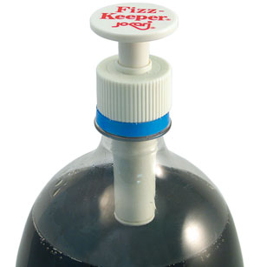
Investigation #5: Pump Air into a soda bottle

Use a two-liter soda bottle emptied and clean. Screw on the fizz pump. This pump allows you to pump air into the soda bottle. Tell students to watch as the soda bottle pumps up. You may also be able to weigh before and after if you have a sensitive scale, but the air will not be as dense as the gym ball demo so the difference may not be detectable. Students will observe the soda bottle becoming more rigid and when the pump is removed they will hear a “whoosh” of air.

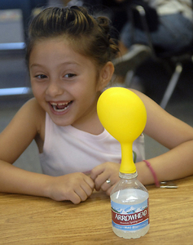
Investigation #6: Alka Seltzers and Balloon

This investigation uses alka seltzers and water, which when being mixed, give off carbon dioxide gas. Use a soda or water bottle filled with an inch of water. Drop two alka seltzers into the water and quickly cover the top with a balloon. If the balloon is too small it may pop, so consider using larger balloons made of thicker material. The CO₂ gas will collect in the balloon. Ask students, “What is filling the balloon? Does air take up space?”

Investigation #7: Alka Seltzers and Scale
There are several ways to conduct this lab activity, but it is probably best done as a demonstration (for elementary students).
You will need an empty wide-mouth soda, water, or juice plastic container. Fill the container with an inch of water. Place the lid on top of the container. Then place 2 alka seltzer tablets on top of the lid. Weigh with a scale sensitive to at least 0.1g (0.01g is even better). Make sure all students see the weight.
Leave the bottle on the scale. Unscrew the lid and place the 2 alka-seltzer tablets inside the lid. Quickly turn the lid over (dropping the tablets in the water and screw lid back on bottle, allowing the tablets to drop in the water without letting too much air escape. As the tablets decrease, have students note the mass is still the same even though the bottle is expanding with air. Point out that the size of the tablet is decreasing, but air is increasing. The mass stays the same, so there is the same amount of “stuff” in the bottle, it’s just changing from solid to gas. Then unscrew the lid slowly to release the air. Watch the mass go down as air escapes. Ask students, “Does the air (that came from the solid) have mass? Did it take up space?”
Alternative: Suspension system
You will need an empty wide-mouth soda, water, or juice plastic container. Fill the container with an inch of water. Place two alka seltzer tablets in a mesh square cloth. Tie the cloth with a thin string (such as fishing line), dangling the mesh inside the plastic container just below the opening. Leave part of the string outside the container and screw on the plastic lid. Weigh the container on a scale sensitive to 0.01g (0.01g is even better).
Then, turn the container upside down on the scale and allow the water to react with the alka seltzer. The bottle needs to be able to balance upside down so a wide mouth container may work best. Have students note that the mass is still the same. Point out that the size of the tablet is decreasing, but the air is increasing. The mass stays the same, so there is the same amount of “stuff” in the bottle, it’s just changing from solid to gas. Then flip the bottle over and unscrew the lid slowly to release the air. Watch the mass go down as air escapes. Ask students, “Does the air (that came from the solid) have mass? Did it take up space?”

NOTE: IT IS VERY IMPORTANT TO POINT OUT THAT THE SOLID TABLETS ARE GETTING SMALLER AND THAT GAS IS INCREASING. SINCE THE MASS STAYS THE SAME, STUDENTS MIGHT CONCLUDE THAT GAS DOES NOT HAVE MASS. THEY NEED TO SEE THAT THE MASS STAYS THE SAME BECAUSE THERE IS THE SAME AMOUNT OF STUFF INSIDE THE CONTAINER (CHANGING FROM SOLID TO GAS). ALSO, THE RELEASE OF AIR SHOULD CAUSE THE MASS TO GO DOWN INDICATING THE AIR DOES HAVE WEIGHT.
Name: __________________________________________ Date: ________________

My Observations of Air
In the table below, write down what you observe during each investigation. Describe as much as possible, what you see happening in the investigation.
Investigation #1 and 2  Air was in bubbles that moved back and forth between the cup  Air provided space that kept the napkin dry | Investigation #3  The balloon got bigger when more air was blown into it. It changed size.
Investigation #4  The ball gets bigger when air is pumped into it. The ball weighed more with air inside. | Investigation #5  The air made the bottle hard; it got harder to pump air into the ball when it was getting full; there was a “whoosh” sound when the cap was taken off
Investigation #6  Alka seltzers made lots of air bubbles; the balloon got bigger and bigger; the alka seltzers got smaller and smaller | Investigation #7  The tablets made lots of bubbles and the soda bottle become very hard. It weighed the same even though it was getting harder. It weighed less when the cap was removed.

Questions:

- Is air matter? Why or why not?
_Air is matter because it takes up space and has weight like solid and liquids. We can’t see air, but we can see things that let us know that air is there and it is matter.
____________________________________________________________________________________

- Do you think air can cause something to gain weight? Why or why not?
The air caused the ball to gain weight, so air can cause things to gain weight. It is matter and has weight. ____________________________________________________________________________________

- Do you think air can cause something to lose weight? Why or why not?
The air caused the soda bottle to lose weight, so air can cause things to lose weight. It is matter and has weight. _______________________________________________________________________

Activity 6: What is Energy? (Forms of Energy)

Overview:
Introduction/Students’ PK on Energy ~10 minutes
Reading about Forms of Energy with Discussion ~25 minutes
How Ideas Have Changed ~10 minutes

Total time: 45 minutes

Purpose:
The way the word ‘energy’ is used in daily life is very different from the way it is used in the scientific sense. Based on their colloquial language and daily life experiences, students have constructed a lot of ideas about energy. In their mind, energy is a type of power that mostly associated with movement, activities, or life; it can be replenished by sleeping, rest, eating food, drinking water or taking in fresh air.. Some of these ideas such as associating energy with motion and foods are correct. Some are not. In this activity, we introduce the notion of Forms of energy. A list of forms of energy is introduced with explanation about how to identify each form of energy based on its evidence such as warmth, motion, light and so on. Our list of forms of energy is deliberately incomplete. We introduce the forms of energy that are most important for understanding carbon-transforming processes. It is important to restrict the discussion to a small number of forms. Some different ways of defining forms of energy are also addressed in this activity.

Materials:
Student copies of My Ideas about Energy
Student copies of reading Forms of Energy
Overhead to document students’ examples of forms of energy

Advance Prep:
- Gather copies of My Ideas about Energy
- Gather copies of Forms of Energy (a reading to be collected and re-used)

Procedures:
Introduction ~10 minutes
- Ask students: “What is energy? What types of do you know about?” Take about five minutes for brainstorming.

Reading: Forms of Energy ~25 minutes
- Pass out Forms of Energy to students. The students will read through Forms of Energy. As students read, stop the class and check student comprehension by asking them to name other examples of that form of energy.

Discussion: Forms of Energy ~5-10 minutes
- Take about 10 minutes to talk with students about each form of energy as a summary of the reading. It is important to address the following 3 points:
- Energy is really hard to define, even for scientists. Forms of energy give us a way of talking about different types of energy, and how energy changes even if energy cannot be “seen”. Forms of energy help us identify energy.
- Energy is always conserved, even as it changes forms. We can always trace energy by looking at how energy changes from one form to other forms.
- There is a difference between matter and energy: unlike matter, energy does not have mass and does not take up space; it is not made of molecules. Matter cannot become energy and energy cannot become matter.

Allow students to share something new they learned about in the reading.

How Ideas Have Changed ~10 Minutes
- Give students a few minutes to write down something new they learned in the reading, or to explain how their ideas have changed. Also let them write 1-2 questions they still have about energy.
- If there is enough time, allow students to share their energy questions, and consider recording these on a class overhead or chart paper to revisit later in the unit.

Name: ___________________________________________ Date: ____________

My Ideas About Energy

We use the word “energy” all the time. But what does this word mean? Think about what the word “energy” means to you. Use the space below to write about your ideas.
__Energy helps you run and stay awake. When, after you use a lot of energy, you feel tired and need to rest. We get energy from our food and the stuff we eat and drink. (These are some of students’ common understanding of energy. They are not the scientific meanings of energy.)
________________________________________________________________________________________________________________________________________________________________________________________________________________________________________________________________________________________

Now, let’s read about energy.

You have just read about different forms of energy. How have your ideas about energy changed? Did you learn something new or different from what you wrote above?
___There are different forms of energy and energy changes forms. There is light energy, motion energy, chemical energy, electrical energy, and heat.
________________________________________________________________________________________________________________________________________________________________________________________________________________________________________________________________________________________

Do you have any questions about energy or forms of energy?

Question 1: ____________________________________________________________
______________________________________________________________________
Question 2: ____________________________________________________________
______________________________________________________________________
Forms of Energy

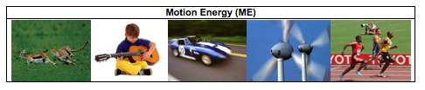Look around you. Many things are moving. They are in motion. Clouds drift across the sky. Leaves fall from the trees. A car speeds by. Birds fly. Whenever there is motion, we “see” motion energy. Holland is using wind energy, because it is clean and does not cause global warming. Wind energy is a kind of motion energy, because wind is moving air. Sound has energy. Sound energy is a special kind of motion energy. It is caused by vibration – the back and forth motion of air molecules.
Can you think of other examples of kinetic energy that you see every day?

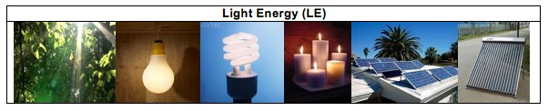
We use light every day. We use it to see things. Without light, our lives would be very difficult. Light helps our life more than just to help us see things. Sunlight helps plants grow. Doctors use special light to perform surgery. Light has light energy. When the lamp is turned on, it gives off light energy. When a candle is burning, the flame gives off light energy.
The light energy from the sun is sometimes called solar energy. The sun is a giant ball of burning gas. It gives off light all the time. It will keep shining and giving us energy for millions of years. Plants capture and use light energy to make their own food. Scientists have also invented ways to use light energy. Solar collectors on house roofs can capture light energy and use it to heat the water in the house. Solar cells on cars and house roofs can also capture light energy and use it to make electricity.
Can you think of other examples of light energy that you see every day?

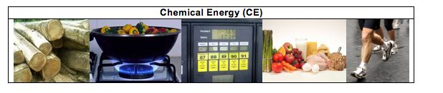Chemical energy is the energy stored in some special materials. Foods, fuels and body parts of all living things are made of materials that contain chemical energy.
All living things are made of cells. The food we eat has chemical energy that helps power our cells. The chemical energy in food helps cells do their jobs in our bodies. Chemical energy helps muscles cells work when we run. It helps brain cells work when we think. Chemical is very important for our bodies.
Like food, fossil fuels are another special material with chemical energy. Fossil fuels come from plants and animals living millions of years ago. The plant and animals were buried underground. Over long periods of time, they turned into fossil fuels. There are three types of fossil fuels – oil, natural gas, and coal. We use fossil fuels everyday. Our cars are powered by gasoline. We use methane for cooking. We use propane to barbecue and heat homes.

Can you think of more examples of things that have chemical energy?
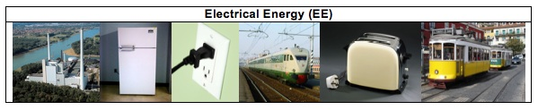
People use electricity everyday. Your family uses many electrical appliances at home. You may watch TV after dinner. Your parents may use a laptop for work. You may use a toaster to toast bread or use a microwave oven to warm your food. To make these machines work, you plug them into an outlet on the wall. What the machines get from the outlet is electricity.
We not only use electricity to power our homes, school, or other buildings, but also use it for transportation. Electric trains or subway trains have engines that run on electricity. These engines get electricity through a metal rail under the train, or from wires at the top of the train.
Electricity has electrical energy. Electricity is generated by different types of power plants. Wind power plants use wind to generate electricity. Nuclear power plants split uranium atoms to make electricity. Hydropower plants use the energy of moving water to make electricity. Fossil fuel fired power plants burn fossil fuels to generate electricity. In the United States, about 51% of our electricity comes from burning coal.
Do you know where your electricity comes from? What type of power plant sends electrical energy to your home?

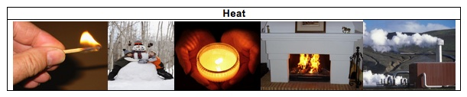
When you run a car for a while, the front of the car becomes very hot. When a flame from a candle or a campfire is burning, you can feel the warmth. When you are exercising, you also feel very hot. Even when you are playing outside on a cold winter day, your body stays warm. Your body temperature always stays close to 98.6°. In all these events, heat or heat energy is released. Geothermal energy is the heat within the earth. Geothermal power plants use the steam or hot water from the earth to generate electricity. Heat is a special form of energy. Whenever changes happen, heat is always given off to the outside of the system. Unlike light energy and chemical energy, heat cannot be “caught” by any living organism to help their body function or to help them move.
Examples of Forms of Energy

MOTION | LIGHT | CHEMICAL | ELECTRICAL | HEAT

Activity 7: How Does Energy Change?
Note: This activity can be completed in conjunction with Activity 6.

Overview:
Review different forms of energy ~ 5 minutes
Introduce Energy Process Tool ~ 10 minutes
Transformations and Energy Process tool ~ 30 minutes

Total time: 45 minutes

Purpose:
Activity 6 helps students to identify energy based on observable or perceptual energy evidences. Activity 7 helps students to trace energy—using the energy process tool to constrain processes.
Elementary students tend to understand energy as a type of power, which can be created and used up. For example, they may say that energy can be created by sleeping or rest. Or, energy is always used up and needs to be constantly replenished. This is different from the scientific concept of energy, which is an abstract quantity that always conserves and degrades. Some elementary students may show commitment to energy conservation, but they tend think that energy can be converted into or from matter (e.g., food changes into energy). In science, energy cannot be converted from or into matter except in nuclear reactions.
This activity introduce two fundamental principles of energy—energy conserves separately from matter and energy conserves with degradation (i.e., heat is always released) by the energy Process Tool,. The focus is on energy conservation. The idea is that whenever there is energy input (represented by the incoming wavy arrow), there is always energy output (represented by the outgoing wavy arrow), so energy cannot be either created or destroyed and energy cannot be changed from non-energy things such as matter. Also, the energy output always contains heat, so not all energy can be used to do useful work or be passed on from one organism to another.
This activity intends to introduce the Energy Process Tool using the simpler events of machines working. Students will observe how several scientific toys work and figure out how energy is transformed in each event. These events are easier to analyze than biological or chemical events since they do not involve matter transformation. Students are expected to understand energy transformation in this activity, but they will eventually use the tool to make sense of both matter and energy transformations in biological changes.

Materials:
Copy of List of Energy Forms
Student copies of How Can Machines Work?
Large Process Tool- use for each machine (toy)
PowerPoint or transparencies: How Can Machines Work.ppt
Energy “Toys” and Lamp

Advance Prep:
- Make copies of student handouts if not provided by MSU
- Make sure process tool is ready to use or consider using PowerPoint/overheads of the process tools
- Gather Energy toys

Procedures:
Introduction ~5 minutes
- Ask students: “what is energy? What types of energy do you know about?” Take about five minutes for brainstorming. Tell students that today they are going to learn how energy changes to different forms. Point to the Energy Poster and explain that today they will only talk about four forms of energy: light, motion, heat, and electrical.

Introduce Energy Process Tool ~10 minutes
- Introduce the two energy principles: energy conservation and energy degradation. Define these for students. Make sure that students understand how the two energy principles are related: the total amount of energy is conserved, but the amount of useful energy always decreases due to heat dissipation (degradation). See “Notes to Teacher” below.
Tell students that they are going to do an activity where they show how energy is conserved by tracing how it changes in different types of machines.
- Show students the Energy Process Tool and tell them it is going to help them show how energy is conserved even when energy is changing forms. Use an example (e.g., lamp lighting up) to model how to use the process tool in explaining energy transformation in processes. Use the large-size process tool, which is made of magnetic board and labels. Show that energy originally starts as Electrical Energy and changes to Light Energy and Heat.

Use Energy Process Tool to Explain How Machines work ~30 minutes
- Divide students into groups or partners and pass out How Machines Work. Explain that they are going to use the Energy Process Tools to show how energy changes in different machines. Use three toys to demonstrate four events: radiometer spinning under light, solar car running under sunlight, solar car running with battery, and kinetic flashlight lightening by squeezing the handle. On the student worksheet, How Can Machines Work?, there are questions about the four events. Students observe the demonstration and work together to figure out the energy input and output for each event. They then use this information to finish the blanks and questions on the worksheets. This will take about 15 minutes.
- Allow time for the class to review each energy machine. Have student groups present their “process diagram” for the different energy machines. Allow students to use the class process tool to show their diagrams to classmates. As students share their ideas, ask the other students in class if they agree with the forms of energy and energy transformations that occur. Ask them to explain both how energy is conserved, and if the event shows energy degradation.
- Allow time to discuss the 5th question on the students’ handout: What patterns do you see. Students should note at least 2 patterns that relate to energy: Energy is conserved by changing forms, and heat is always released.

Notes To The Teacher
- Challenges in teaching about energy
Scientific and informal uses of the word “energy.” Scientists sometimes use everyday words to label specific concepts they developed. Energy is one such word. We use the word energy in our everyday language, but energy, as a science word, has a specific meaning; it is an abstract quantity that always conserves. Students hear their mothers remind them to drink enough water, because water will give them “energy.” Students may also feel that they get “energy” from vitamins, sleep, exercise, stimulants, etc… None of these provide energy in the scientific sense.
Distinguishing energy from matter. We commonly suggest that some substances (e.g., glucose, ATP, gasoline) are energy, or that matter can be transformed into energy (e.g., “the wood burned up to produce heat and light”). THIS DOES NOT HAPPEN EXCEPT IN NUCLEAR REACTIONS. This is why it is important to keep matter and energy arrows separate in the matter and energy process tool.
Defining and measuring energy. Unlike matter, energy cannot be seen even from the most advanced microscopes. You can hold a grain of sand in your hand, but cannot hold energy. You can identify evidence of energy or energy transformations. But, what is energy? What is the definition of energy? If you ask this question to scientists, they will give you many different answers. They will also tell you that memorizing a definition of energy is not important.
So, what do scientists know about energy? Why is the concept of energy useful for us? Although we cannot see energy, there is always evidence of energy. In this lesson, we will learn how to identify the six most basic forms of energy. Scientists can measure energy. They can measure the amount of energy you gained from a glass of milk. They can measure the amount of energy used to move a car from the city you live in to New York. They can also measure the amount of energy that operates a light bulb for one hour.
- About the two energy principles.
When scientists measure energy, they find two laws of energy transformation.
- Energy Conservation: The total amount of energy stays the same during a process. Energy cannot be created or destroyed, it always transforms from one form to other forms. Energy always transforms. It cannot be converted into matter in physical and chemical changes.
- Energy Degradation: Whenever energy transforms, heat is always released into the environment as a wasted form. For example, when we use electricity to power machines, a large part of the electrical energy transforms into heat and only a small part of the electrical energy transforms into motion energy to move the machine. When animals move their body, a large part of the chemical energy stored in their body structure transforms into heat and only a small part of that chemical energy transforms into motion energy to move the body.
- Energy transformation involved in toy machines working.
This activity uses toys to introduce the notion of energy transformation. When toy machines move, there is mostly a two-step energy transformation involved. Here are examples:
- When a radiometer spins, first light energy transforms into electrical energy and heat. Then, the electrical energy transforms into motion energy of the radiometer spinning and heat.
- When a toy car is using solar cells to run, first light energy transforms into electrical energy and heat. Then, the electrical energy transforms into motion energy of car running and heat
- When a toy car is using battery to run, first the chemical energy stored in battery transforms into electrical energy and heat. Then, the electrical energy transforms into motion energy of car running and heat.
- When you squeeze the handle to make the flashlight light, first the motion energy transforms into electrical energy and heat. Then the electrical energy transforms into light energy and heat.
To avoid confusion, we only teach the energy input/output and matter input/output without addressing the middle stage of energy transformation (i.e., stage involving electrical energy). When students are learning the Energy consumption and Global Warming Unit, they will revisit some of these events and learn about the middle stage of energy transformation. During that time, students would be familiar with the Energy Process Tool and would have less difficulty in understanding the middle stage of energy transformation.
Name:____________________________________________ Hour:___________

How can machines work?
In this activity, you will use the Process Tool to analyze energy transformation in various events. The incoming wavy arrow represents the energy input into the machines. The outgoing wavy arrow represents the energy output from the machines. Please note that the Energy Process Tool follows the two principles of energy:
- Energy conservation – Energy can transform from one energy form to other energy forms, but the total amount of energy conserves. (Energy cannot be converted into or from matter).
- Energy degradation – You cannot use all of the energy, because whenever energy transforms, heat is always released and released into the environment.
As you look at each machine, decide what FORM of energy flows into the machines and what FORM of energy flows out of the machines. Choose from among the four forms:

Light Motion Electrical Heat

- Radiometer: The radiometer is a light-bulb shaped device with a small weather vane in the middle of it. Place the radiometer under a lamp or sunlight and observe what happens when the light shines on it. Think about what happens inside the radiometer. Please use the process tool to analyze how energy transforms. Fill out the energy input and energy output in the blanks below. You may not need all the blanks.
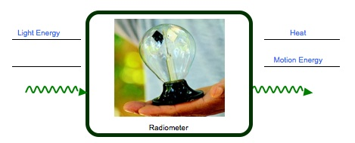

- Solar Car #1: The solar car has a switch at the bottom. It can either run on battery or use solar cells. Put the switch on “solar”. Observe what happens when the car runs on solar cells. Please fill out the energy input and energy output in the blanks below. You may not need all the blanks.

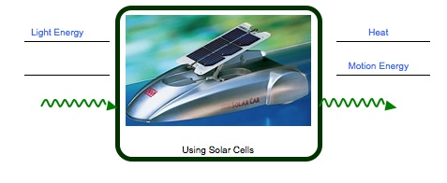

- Solar car #2: Put the switch on “battery”. Observe what happens when the car uses the battery. What is the energy input? What is the energy output? Fill out the energy input and energy output in the blanks below. You may not need all the blanks.

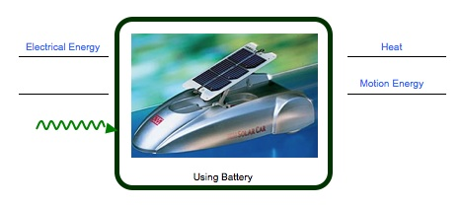
Chemical Energy

- The Flashlight: In order to make the flashlight work, you will need to squeeze the handle back-and-forth. Observe what happens when you squeeze and release the handle. What is the energy input? What is the energy output? Fill out the energy input and energy output in the blanks below. You may not need all the blanks.
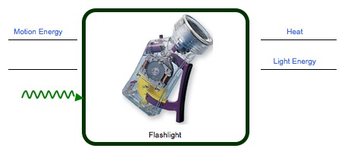

- The four events are all show energy changing from one form to another. What patterns do you see in your four diagrams?
There are two patterns:
1) Energy cannot be created or destroyed. It is transformed from one form to other forms.
2) Energy degradation: Heat is always released.

Activity 8: Energy and Fuels

Overview:
Review Forms of Energy ~5 minutes
Candle Demonstration ~25 minutes
Summary Questions & Discussion ~20 minutes

TOTAL TIME: 50 minutes

Purpose:
The purpose of this activity is to use combustion of a candle as an example to introduce the process tool with both matter transformation and energy transformation. The previous activity, Activity 7 introduces the process tool in a way that only discusses energy transformation. This activity will add matter transformation to the matter and energy process tool.
This activity focuses on two common misconceptions about matter and energy:
1. Matter-energy conversion – energy can be converted into or from matter. In science, energy transformation should be clearly distinguished from matter transformation. (Matter-energy conversion only happens in nuclear reactions.) So, in the matter and energy process tool, energy is represented by the wavy arrows and matter is represented by the straight arrows. The rule is that wavy arrows cannot change into or from straight arrows.
2. Matter is used up or changes without reaction. Some students may understand burning as a process in which fuels and air are constantly consumed and used up by flame. Some students may recognize that burning produce materials such as smoke. but still do not identify gaseous reactants or products such as carbon dioxide, oxygen, and water vapor. So, in the lab, students will observe what happens when different fuels are burning and identify the gaseous reactant (oxygen) and products (carbon dioxide and water vapor) involved in burning. Based on that, they will construct the idea that burning is a chemical reaction involving gaseous reactants and products.

Materials:
Student copies of Burning A Candle (with observation sheet & process tool diagrams)
Large-Size Process Tool
Candle
Lighter
Large glass container (beaker)
Digital scale

Advance Preparation:
Make copies of student handouts if not provided by MSU
Make sure Large-size process tool is ready for use

Procedures:
Review Forms of Energy ~ 5 minutes
- Review the 5 key forms of energy from previous lessons. Review what students learned about chemical energy. Where is it found? (e.g., in foods, fuels, all living things’ body structure). How does matter change? How does energy change? Tell students that today they will learn more about what happens when foods and fuels react with oxygen.

Burning Candle ~25 minutes
- Pass out Burning A Candle worksheet. Students will observe what happens when a candle is burning and record their observations. Ask them to share what they have seen. Ask students, “What happens to the candle if it burns for a long time?”---it gets shorter and shorter until the wax is gone. Students are expected to identify the reactants and products involved in burning. In particular, gaseous matter including water vapor and oxygen should be identified.
- Tell students that they are going to watch a candle burning. But this time they are going to think about 2 things: 1) what is happening to the materials when the candle burns? 2) what happens to the energy?
- NOTE: Have students make initial observations, then allow candle to burn for about 10-15 minutes, then make observation again, especially of mass change.

MATERIALS/MATTER
- Before burning the candle, introduce it and how people use it in everyday life. Ask students to think about the candle.
- Ask students to make prediction: “What materials does the flame need in order to keep burning?” Students may answer wax, wick, etc., they may not recognize that flame also needs air/oxygen to keep burning. Ask students to observe the demo and figure out the answers to the question. Demo: Invert a glass container (beaker) over the flame. After a few minutes, the flame goes out. After students finish their observation, ask them: “Do you think the demo help you to answer the question?” Ask students to write their answer on their Burning a Candle worksheet (Question 1). After students finish, hold a brief discussion on their answers and elicit the idea that flame needs fuel (wax and wick) and oxygen to burn—these are the matter inputs. Use the matter and energy process tool to document that OXYGEN (GAS) and WAX (SOLID) go into the burning process.
- Ask students: “What will happen to the candle when it is burning? What will happen to the weight of the candle (wick and wax) when it is burning? Do you think the candle will keep the same weight, put on weight, or loses weight?” Explain to students that you will use the digital scale to find out the answer. Then put the candle on the digital scale. Read and record the initial weight of the candle. Ignite the candle. While the candle is burning, ask students to vote: will the candle keep the same weight, put on weight, or lose weight? Ask students to explain their votes. After about 5 minute, read the digital scale again and record the final weight of the candle. Compare it with the initial weight of the candle. Ask students: “What happens to the candle? What happens to the weight of the candle?” Ask students to write their answer on their Burning a Candle worksheet (Question 2). After students finish, hold a brief discussion and elicit the idea that the candle lose weight.
- Ask students: “Why does the candle lose weight? Where does the lost weight go? Tell students that you will do another demo to help them to figure out. Demo: While the candle is burning, convert a dry glass beaker over the flame. After a minute, there will be water drops around the inside of the beaker. You can ask some students to come to watch the beaker closely. If you ask them to touch the inside of the beaker, they will feel that it is wet. Ask students: what is produced? Students will record their observations of what happens on their Burning a Candle worksheet. After students finish, hold a brief discussion and elicit the idea that water vapor is produced. Tell students that another product of burning is carbon dioxide. If your students are not familiar with carbon dioxide, tell them that carbon dioxide is the gas that causes global warming. Then use the matter and energy process tool to document that WATER VAPOR (GAS) and CARBON DIOIXDE (GAS) are produced from the burning process.
ENERGY
- Now tell students to pay careful attention to what happens to the energy. Ask students: “What kind of energy is in the wax?” Students may not understand chemical energy well. Ask them to refer to the List of Energy Forms and remind them that foods, fuels, and body parts contain chemical energy. Use the process tool to show that chemical energy is the energy input.
- Ask students, “What forms of energy are observed when the candle burns?” Elicit the answers: heat and light. Complete the process tool.
Summary questions and Discussion ~20 minutes
- Make sure students complete the process tool on their own handouts and then give students about 10 minutes to answer the summary questions.
- Spend the last 10 minutes of class on discussing the questions.
Key Ideas:
Emphasize that burning a candle shows that the materials that make up the solid wax eventually change to gas materials, and that burning actually changes the mixture of air—less oxygen and more water vapor and carbon dioxide.
Also review the idea that fuels are special materials with chemical energy and that burning them gives us other forms of energy that we can use.
If time, consider connecting back to powers of ten—tell them that sometimes things look a certain way at the visible scale, but things could be happening at the smaller or larger scales.

Name: ________________________________________ Date: _________________

Burning a Candle
Record your observations of the candle in the table below.
What happens to materials as the candle burns? | What happens to the energy as the candle burns?
1. What does the flame need in order to keep burning?  Oxygen is used by flame  Candle (wax and wick)  2. What happens to the weight of the wax and wick of the candle?  Wax melts- it changes from solid to liquid; the candle gets shorter if it burns for a long time; the candle loses weight when it burns for a long time.  3. What is produced when the flame burns?  Water vapor is given off by flame | 1. What form of energy do you identify before the candle burns?  Chemical energy of the wax and wick.  - What forms of energy is released when the candle burns?  Light energy and heat are given off by the candle
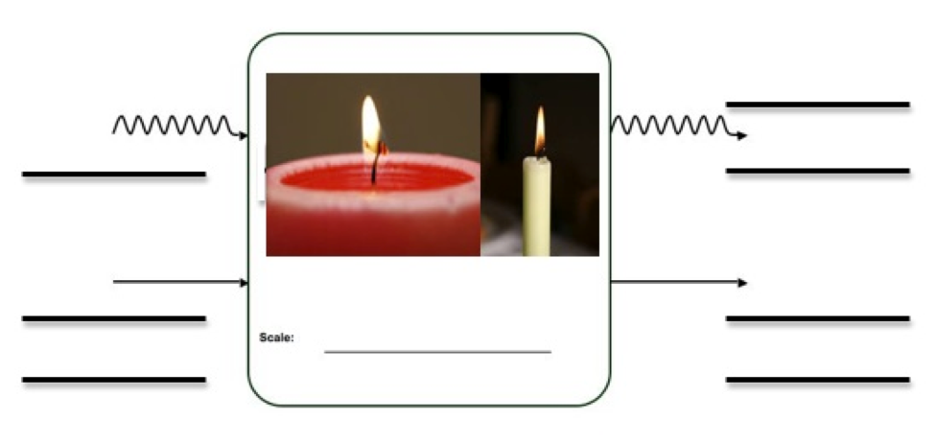
Chemical Energy
Oxygen
Light Energy
Heat
Water/water vapor
Carbon dioxide or other gases/air
Solid/Liquid Wax

Questions

- When you use digital scale to measure the weight of the candle, what did find? Does it lose weight? If yes, where does the lost materials go?

___The wax changes to gases and goes into the air.____________________________ __________________________________________________________________________________________________________________________________________________________________________________________________________________

- Wood and wax can burn, but water, sand, and stone cannot burn. Some materials are called fuels. Fuels can burn, which means energy must come from fuels. What type of energy do fuels have?

___Fuels have chemical energy ____________________________________________
______________________________________________________________________

- How does the energy change as the fuel burns?

______The chemical energy in the wax changes to light energy and heat. ___________
__________________________________________________________________________________________________________________________________________________________________________________________________________________

Activity 9: Air is a Mixture

General Overview:
Review of Investigations of Air and Candle ~10 minutes
Teacher reading of Air is a mixture ~10 minutes
Student work How Does Air Change? ~15 minutes
Discussion How Does Air Change? ~15 minutes

Estimated Time: 50 minutes

Purpose:
This lesson is designed to get students thinking about air in terms of its gaseous components. Students will primarily discuss air as matter in relation to its molecular components. Whereas students have discussed different forms of matter and conducted simple investigations to show that air has similar macroscopic characteristics of matter—that it takes up space and has mass, and that it changes during a process, they will likely still consider air as different from solids and liquids. At this grade level, it is important for students to recognize that air is a mixture of different kinds of gases, mostly N₂ and O₂ with small and sometimes variable amounts of other gases, such as CO₂, and water vapor (H₂O). They may also recognize other substances mixed in air, for instance, dust, germs, and smell of substances. Moreover, it is important for students to recognize that processes such as flame burning changes the mixture of air by increasing or decreasing the amount of CO₂, O₂, and H₂O. Like all matter, air is made of molecules, which are so tiny that they are invisible. Also the air molecules are constantly in motion.

Materials:
Student copies of Air is a Mixture Reading (collect and re-use reading)
Student Copies of How Is Air Changed

Advance Preparation:
- Gather copies of Air is a Mixture
- Gather Copies of How is Air Changed

Procedures:
Review Investigations ~10 minutes
- Tell students that today they will continue to learn about characteristics of air, but that they are going to use those ideas to explore what air is made of and how it changes in processes. Begin by reviewing what students observed and what they concluded about air—is it matter or non-matter? Also review what students learned in Activity 8 about how flames change matter.
- Then, make it explicit that at the visible macroscopic scale, air seems like “nothing”. But that there are macroscopic characteristics that tell us it is matter, even though we cannot always see it. When we move down powers of ten, air is actually a mixture of a lot of different things.
Reading Air is a Mixture ~10 minutes
- The teacher and/or students can read-aloud Air is a Mixture. While reading, probe students’ ideas about “mixture” and have students share examples of mixtures they know of in their lives (milkshakes and most foods and beverages, wood, gasoline, clothing, spice mixes, cake, cookie, brownie mixes, etc).

- Read through the different gases that make up air. Explain to students that the air they observed in Activity 5—the air that took up space and had mass—is a mixture of different gases. Read about the different gases. As you read, ask students where they have heard about each gas.
How Is Air Changed ~15 minutes
- Pass our How Is Air Changed to students. Explain that all living things take in air or gases. Students will brainstorm why living things need air or gases (have them share their examples). For example, people need oxygen and breathe out carbon dioxide (during cellular respiration). Plants do the opposite (during photosynthesis). Students might also know that flames need oxygen to burn.
- Use the flame to model how students are supposed to engage in this activity. Review what students learned about the burning candle including what gas went in (oxygen) and what gases were given off (carbon dioxide and water vapor). Then tell students to take about 10 minutes to write about how plants, animals, and decomposers change the air around them. Ask them to write as much as they know about this.

Discussion ~15 minutes
- Discuss each example from the How Is Air Changed handout. Consider using the process tool to demonstrate the gases going in and out of each example. Make sure to ask students how the air mixture would change. For example, will there be more or less carbon dioxide in the air we breathe out compared to the air we breathe in.

Reading: Air is Mixture


We speak of air as light, “airy,” or even as nothing. But what is air made of? Today you will learn more about the different materials that make up air.
Air is a type of matter. Air takes up space and has weight. The air around us is made of mostly gases, but it also includes some liquids like water droplets, and solids like dust. This is why we call air a mixture.
A mixture is a material made from more than one thing. A milkshake is a mixture. It contains many types of liquids, like milk and strawberry syrup. It also has tiny solid pieces of ice in it.
Can you think of other things that are a mixture?
Like the milkshake, air is also a mixture of different materials. It is a mixture of gases. What makes up air changes from moment to moment and place to place, but about 78% of air is made of a gas called nitrogen. About 21 % of air is made of oxygen gas, and about .03% of air is made of carbon dioxide gas. There are other gases in air, such as hydrogen, helium, and argon. Water vapor is also a gas found in air.
There are other things found in air, including dirt, germs, bacteria, smoke, and many others. Most things you can see in the air, like dust or smoke, are made of solids.
Things can change the mixture of air around them. First you will read about the different gases that make up air. Then you will share your ideas about how plants, animals, decomposers, and flames change the air around them.

Reading: Gases That Make Up Air


Oxygen
All plants and animals need oxygen to live. Oxygen makes up 21% of the air in our atmosphere. This gas helps people stay alive. When people are in the hospital, they might wear an oxygen mask that gives them even more oxygen to breathe than they would get from normal air.

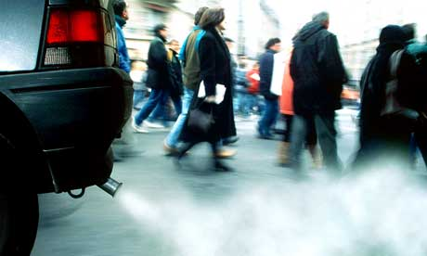
Carbon Dioxide
Carbon dioxide is a gas that all living things give off into the air. This gas makes up less than 1% of the air in our atmosphere, but it is a very important gas. When we burn gasoline in our cars, carbon dioxide gas is given off into the air. When we burn wood and candle, carbon dioxide is also given off.
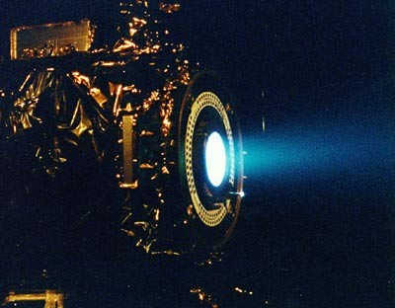
Nitrogen
There is a lot of nitrogen gas in our atmosphere. Nitrogen makes up 78% of the molecules in the air around us. Some rockets give off nitrogen gas. Satellites that orbit Earth also use nitrogen gas to move around space.

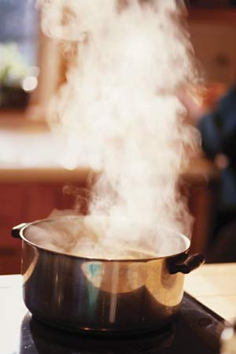
Water Vapor
Water vapor is one of the three states of matter for water. It is the gas form of water. Water vapor molecules make up 0-3% of the air in the atmosphere. Water vapor gas is invisible but when these gas molecules condense they form tiny droplets that we can see as steam, fog, or clouds.

Name: ______________________________________________ Date: __________

How Is Air Changed?

Now that you know air is a mixture of gases, think about how plants, animals, decomposers, and flames change this mixture. Write down your ideas below.

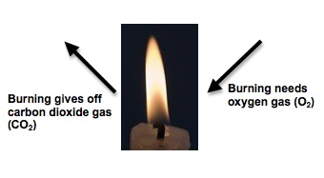
Burning Fuels & Flame
1. Look at the arrows going into and out of the flame. Oxygen is needed to burn things and carbon dioxide is given off. How does a flame change the mixture of air around it?
The flame uses oxygen from the air and it gives off carbon dioxide and water vapor, so there is less oxygen and more carbon dioxide and water vapor in the air around it.

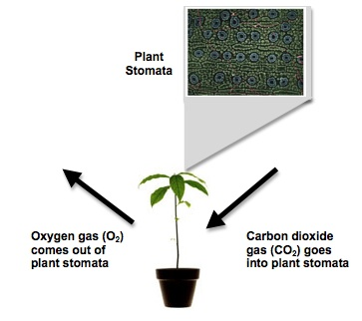
Plants
2. Look at the arrows going into and out of the plant. You may have heard that plants take in carbon dioxide and give off oxygen during the process of making food (photosynthesis). How does the plant change the mixture of air around it?

The plant uses carbon dioxide from the air in photosynthesis and it gives off oxygen, so there is less carbon dioxide and more oxygen in the air around it.
__________________________________

Animals
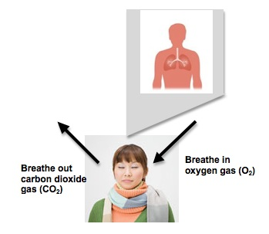
3. Look at the arrows going into and out of the person. You may have heard that people and other animals breathe in oxygen and breathe out carbon dioxide. How does a person change the mixture of air around them?
A person uses oxygen from the air (in cellular respiration) and s/he give off carbon dioxide, so there is less oxygen and more carbon dioxide in the air around the person. _______

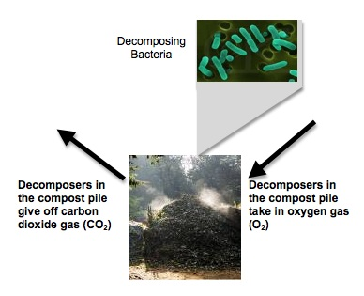
Decomposers
6. Look at the arrows going into and out of decomposers in the compost pile. Decomposers need oxygen to decompose dead plants and animals. They give off carbon dioxide. How do decomposers change the mixture of air around them?

__ Decomposers use oxygen from the air and they give off carbon dioxide, so there is less oxygen and more carbon dioxide in the air around the decomposers. ___________________________

In chemical changes, matter and energy are not convertible, but in changes happened within atoms—nuclear reactions, matter-energy conversion will take place. Our research convinces us that students are unlikely to understand how matter and energy change in nuclear reactions without first learning to conserve energy and matter as separate entities.
Atomic force microscopes can create images of individual atoms or molecules, but the light microscopes that students are familiar with cannot.
The Powers of 10 video shows both smaller scales (sub-atomic) and larger scales (global, solar system, galaxy, universe). While it is good for students to be aware of these systems at smaller and larger scales, we will not use them in our materials on carbon-transforming processes.
In this unit and in all our materials we treat matter and energy as separate entities that are separately conserved. Our research on student reasoning convinces us that this understanding is a necessary developmental predecessor to more sophisticated understandings based on Relativity and Quantum Mechanics.
In this unit and in all our materials we treat matter and energy as separate entities that are separately conserved. In chemical changes, matter and energy are not convertible, but in changes happened within atoms—nuclear reactions, matter-energy conversion will take place. Our research convinces us that students are unlikely to understand how matter and energy change in nuclear reactions without first learning to conserve energy and matter as separate entities.
Although wick is also the fuel for the flame to keep burning, it takes up a very small part of candle. To simplify the problem, we usually do not write it on the process tool.

