Environmental Literacy Carbon Interview
Name ___________________ Grade __________ Age _____________

--- Interview 1: Categorization ---
Introduction
The interviewer introduces himself/herself to the student:
- Name and the country and why you are in US.
- Today we will talk about some materials you see everyday such as wood, water, and sand. We will also talk about plants and animals. We need your help to understand how elementary students think about these materials, plants, and animals. We are not interested in just “right answers”. So, if you could tell me what you think, that would be really helpful for our research. If you think that my question does not make sense to you, just let me know. By that, you help us to understand that our question is not good enough.
- Ask about the student’s name, grade, and age.

--- Part 1. Organisms and Artifacts (20 minutes) ---
- Sorting (less than 5 minutes)
- Could you sort these cards into groups?
- How are these groups different from each other?

- Explaining Sorting
- Show students three groups: A. Corn plants and people; B. Burning match and burning candle; C. Rotten apple and decaying trees. For each group, ask a set of questions – function questions; matter/structure questions; energy questions.
- Show students the representation pictures: Here are some pictures. You can use them as resources to answer my questions.

Group 1: Corn plants, Tree, Cow, People
1. Function Questions (growing, eating, and breathing):
People and cow
- People and cow can grow. What do they need in order to grow? – Students may list a set of enablers such as eating/foods, breathing/air, warmth, sunlight, and so on.
- How do the things you mentioned help people and cows to grow? – Ask students to explain each of the enablers s/he listed.
- Is it possible that people and cows can grow without the things you mentioned? – Ask the student whether it is possible that people can grow without each of the enablers the student listed.
- Does the girl’s body have smaller parts? What are those parts? When the girl is breathing/eating, what are those parts of her body do?

Corn Plants and Tree
- Plants can also grow. What do corn plants need in order to grow? – Students may list a set of enablers such as foods, light, air, warmth, and so on.
- How do the things you mentioned help plants to grow? – Ask students to explain each of the enablers s/he listed.
- Is it possible that the plants can grow without the things you mentioned? – Ask the student whether it is possible that plants can grow without each of the enablers the student listed.
- Does the plants have smaller parts? What are those parts? What do those parts do when the corn plants are getting water, making food, or getting air?

2. Structure & Matter questions:
- What are the girl’s body, corn plants, the tree, and the cow made of? Are they made of similar materials? What are those materials?

3. Energy Questions
- Do you think that people, corn plants, the tree, and the cow need energy to grow?
- If the student answered yes, ask the following questions: 1) Where does the energy come from? 2) How does people’s body (or corn plants) use the energy? 3) Where does energy go when it is used?
- If the student answers no, ask the following question: Why do you think that people do not need energy to grow?

Group 2: Burning match, burning candle
1. Function Questions (burning):
- Here are two pictures showing that the match and the candle are burning. You can see the flame. What does the flame need in order to keep burning? – Students may list a set of enablers such as match/candle, air, and so on.
- How do the things you mentioned help to keep the flame burning? – Ask students to explain each of the enablers s/he listed.
- Is it possible that a flame can keep burning without the things you mentioned? Is it possible to have a flame that doesn’t burn up some kind of fuel? Why or why not? Is it possible to have a flame that keeps going by burning water? Or, a stone? Why or why not? – Ask the student whether it is possible a flame can keep burning without each of the enablers the student listed.

2. Structure & Matter questions:
- When the match is burning, what will happen to the wood that makes up the match? When the candle is burning, what will happen to the stuff (or wax) that makes up the match?
- What do you think the flame is made of? Do you think the flame is some type of matter? Is the flame energy?

3. Energy Questions
- Do you think the flames need energy to keep burning?
- If the student answers yes, ask: Why do they need energy to burn? Where does the energy of burning come from? Where does the energy go when the flame is out?

Group 3: Rotten apple, decaying tree
1. Function Questions (rotting and decaying):
Rotten Apple
- What happened to the apple? Is there anything that causes this to happen? – Students may list a set of enablers such as the apple getting old, being lack of life necessities, wind, sun, warmth, and so on.
- How do the things you mentioned make the apple to rot? – Ask students to explain each of the enablers s/he listed.
- Is it possible to keep an apple from rotting? How can you do this? How or why does [your action] stop the process of rotting? – Impossible questions.
- If you look at this picture (Close-up picture of a rotten apple), you will see some white stuff here. What is that? Do you think this picture can help you understand what cause the apple to rot?

Decaying tree
- What happened to the tree? Is there anything that causes this to happen? – Students may list a set of enablers such as the apple getting old, being lack of life necessities, wind, sun, warmth, and so on.
- How do the things you mentioned make the tree to decay? – Ask students to explain each of the enablers s/he listed.
- Is it possible to keep a tree from decaying? How can you do this? How or why does [your action] stop the process of decay? – Impossible questions.

2. Structure & Matter questions:
- What is the rotten apple made of?
- What is the decaying tree made of?
- When the apple/tree is rotting, what happens to its materials?

3. Energy Questions
- Do you think these two pictures have anything to do with energy? Please explain your answer.
- If the student said yes, ask the following questions: Does the apple have energy before it rots? What will happen to that energy when the apple is becoming rotten?
Does the tree have energy before it rots? What will happen to that energy when the tree is decaying?
- If the student answered no, ask why does s/he think so?
Pictures used for sorting organisms and artifacts:

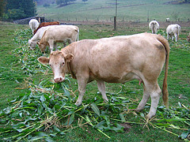  Cows | 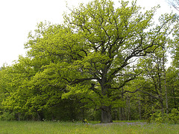  Trees
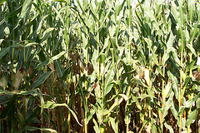  Corn Plants | People
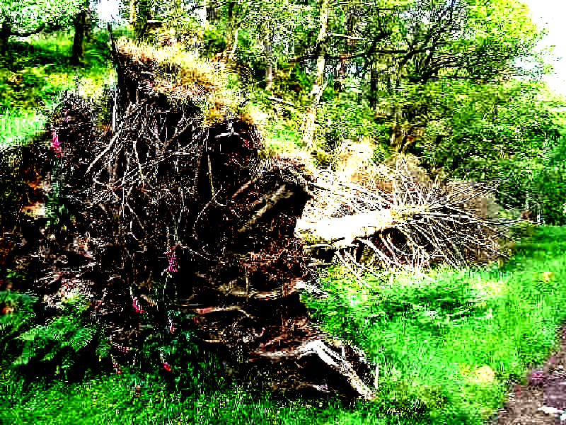  Stone | Rotten Apple
  Burning Match | 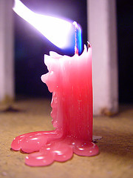  Burning Candle

Pictures for representation questions in the activity of sorting organisms/artifacts:

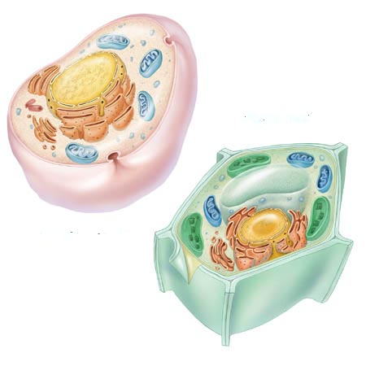  Animal Cell and Plant Cell | Human Digestive System

Structure of flame

Close-up picture of a rotten apple

--- Part 2. Materials (10 minutes) ---
- Could you sort these cards into groups? How are the groups different from each other?
- A scientist sorted these cards like this: Group A – meat, bread, and sugar; Group B – coal, wood, and gasoline; Group C – limestone, sand, and water.
- Why does water go with stone and sand instead of bread and meat?
- The scientist said that these two groups are (A and B) alike. Do you know why?
- Do you think the things in one group are made of similar material?

Pictures for sorting materials:

Water | Meat
Bread | Sugar
Wood | Coal
Stone | Sand
Gasoline

